LECCIÓN 1A
Examen A (37 points)
VOCABULARIO
A. Listen as your instructor says a number. Select the number that precedes it.
1. a. 5 b. 15 c. 17
2. a. 21 b. 20 c. 19
3. a. 3 b. 13 c. 23
4. a. 1 b. 10 c. 20
5. a. 29 b. 12 c. 2
B. Paso 1. Supply the days of the week that are missing from the top of the chart. Spelling counts!
Paso 2. Fill in five squares with information about Marlene’s schedule that your instructor will read. Do not fill in more than five squares.
 | LUNES |  |  | JUEVES |  | SÁBADO
por la mañana | Historia  del Arte | trabajo |  | descanso |  |  | descanso
por la tarde |  |  |  | trabajo
por la noche
C. Write down each time of the day your instructor reads in the spaces provided. Be sure to include the equivalents for a.m. or p.m.
1. 4.
2. 5.
3.
D. Complete each action with the most logical item from the column on the right.
1. tocar  2. hablar  3. llevar  4. tomar  5. llegar | a. una cerveza  b. a la universidad  c. el piano  d. doce créditos  e. con los amigos (friends)
GRAMÁTICA
E. Paso 1. Using the information you wrote about Marlene’s schedule (see activity B, Paso 2), write two sentences in which you compare two activities in your schedule with Marlene’s.
modelo: Marlene descansa los jueves por la mañana, pero yo estudio.
1.
2.
Paso 2. Using one of the activities from Paso 1, create a question to ask one of your Spanish classmates about his or her schedule.

F. Think of your best friend and write one sentence in which you mention one activity the two of you both like to do on weekends. Start your sentence as follows.
(Friend’s name) y yo...

G. Using necesitar + infinitive, mention one thing that you need to do to learn Spanish. Then indicate whether you do it or not.
sí  no 
H. Using the appropriate possessive adjective (mi, tu, su, and so forth), answer the following questions in Spanish and in complete sentences. The information you provide must be truthful.
1. What is your instructor’s name?

2. In which city is your and your classmates’ university located?

CULTURA (Optativo)
I. Answer the following questions based on what you have learned in the Vistazos culturales sections.
1. A student from Spain gets a sobresaliente in a Chemistry class. What would be the equivalent grade in this country?
a. C b. F c. D d. A
2. Sunday is the first day of the week in most of the Spanish-speaking world. ¿Cierto o falso?

3. You are looking at train schedules in a station in Spain. How is the departure time of a train most likely to be listed?
a. 18:10 b. 6:10 p.m. c. a las seis y diez de la tarde
J. Answer the following based on what you have learned in the Panorama cultural section.
1. Hay unos millones de personas que hablan español en el mundo.
a. 250 b. 350 c. 450
2. La apariencia física de las personas hispanas muestra (shows) mucha diversidad. ¿Cierto o falso?

3. Solo cinco escritores hispanos han ganado (have won) el Premio Nóbel de Literatura. ¿Cierto o falso?

LECCIÓN 1A
Examen B (37 points)
VOCABULARIO
A. Write down the telephone numbers your instructor reads.
1. 4.
2. 5.
3.
B. Paso 1. Supply the days of the week that are missing from the top of the chart. Spelling counts!
LUNES |  |  | JUEVES |  | SÁBADO
Historia del Arte | Composición | Historia del Arte | Composición | Historia del Arte | trabajo | descanso
 | Italiano I | Italiano I | Italiano I | Italiano I | trabajo
Biología I | Biología I | Biología I |  | Biología I | trabajo | estudio
trabajo | trabajo |  | trabajo | trabajo
Paso 2. Listen as your instructor makes a series of statements about Daniel’s class schedule above. Indicate whether the statements are cierto or falso, based on Daniel’s schedule.
1. 2. 3. 4. 5.
C. Listen as your instructor asks you a series of questions about your schedule. Your answers need not be in complete sentences, but they must be truthful.
1.
2.
3.
D. Look at the following digital clocks and give the times in Spanish. Be sure to include the equivalents for a.m. and p.m.
 | 4:45 p.m. |  | 1:11 a.m. |  | 10:30 p.m.
1. 2. 3.

 | 8:25 a.m. |  | 1:54 p.m.
4. 5.

GRAMÁTICA
E. Paso 1. Using four different verbs from the following list, write four complete sentences about what you think your instructor’s weekly schedule is. Make sure you mention the day of the week and time of day when you think he or she does each activity. He or she will check the appropriate Sí/No box to let you know whether you guessed correctly or not.
bailar enseñar hablar practicar preparar tomar
sí no
1.  
2.  
3.  
4.  
Paso 2. Choose one sentence from Paso 1 and compare it to your schedule. Do you do the same or not? Answer in a complete sentence.

F. Paso 1. Complete the following sentence by choosing one activity from the list that both you and your friends do on a typical weekend.
charlar descansar escuchar estudiar trabajar visitar
Mis amigos/as y yo
Paso 2. Using the list from Paso 1, write a sentence about one thing your friends do that is different from what you do on a typical weekend.
Mis amigos/as
G. Using desear + infinitive, mention one thing that you want to do this coming weekend. Then indicate whether you think you will be able to do it or not.
sí  no 
H. Match the possessive adjective in the column on the left with the appropriate phrase from the column on the right. There are several correct matches for each phrase, but use each item only once. Then indicate whether you agree or not with the completed phrase.
1. Nuestra...  2. Su (your instructor’s)...  3. Mi...  4. Nuestros...  5. Sus (your classmates’)...  6. Nuestras... | a. libros están en las mochilas.  b. profesores son buenos (good).  c. clase de español tiene diecisiete estudiantes.  d. clases son interesantes.  e. biblioteca es excelente.  f. actitud es buena. | sí no                  
CULTURA (Optativo)
I. Answer the following questions based on what you have learned in the Vistazos culturales sections.
1. You are looking at a Latin American student’s transcript. Which of the following ways to report a grade would you see in his or her transcript?
a. B
b. notable
c. 8
d. 3 créditos
2. In most of the Spanish-speaking world, the first day of the week is .
3. You are at the Barajas Airport in Madrid (Spain) waiting for your flight back to this country. How is the departure time of your flight most likely to be listed?
a. 2:10 p.m.
b. 14:10 p.m.
c. a las dos y diez
d. 14:10
J. Answer the following based on what you have learned in the Panorama cultural section.
1. Hay países donde el español es lengua ofícial.
a. 21 b. 25 c. 28
2. escritores hispanos han ganado (have won) el Premio Nóbel de Literatura.
a. Cinco b. Diez c. Doce
3. En Sol y viento, se usa latino para referirse a...
a. todas las personas de ascendencia hispana
b. los hispanos de los Estados Unidos
c. a y b
LECCIÓN 1B
Examen A (43 points)
VOCABULARIO
A. Your instructor will read a series of answers. Match what you hear with the most appropriate
question word.
1. a. ¿Qué? b. ¿Por qué? c. ¿Cuántos? d. ¿Dónde?
2. a. ¿Quiénes? b. ¿Qué? c. ¿De dónde? d. ¿Cuándo?
3. a. ¿Cuál? b. ¿Por qué? c. ¿Qué? d. ¿Dónde?
4. a. ¿Cómo? b. ¿Por qué? c. ¿Cuánto? d. ¿Cuándo?
5. a. ¿Cuándo? b. ¿Cómo? c. ¿Dónde? d. ¿Quién?
B. Paso 1. Listen as your instructor reads a series of descriptions about the weather. Write the letter of each description below the drawing that illustrates the weather described.
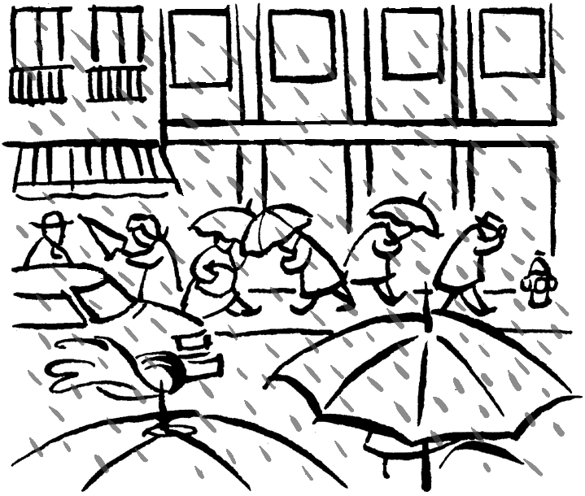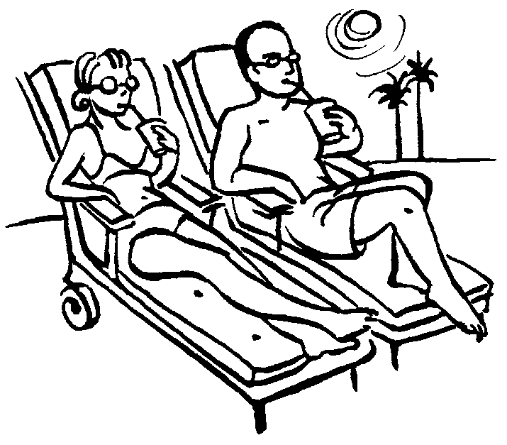
1. 2.
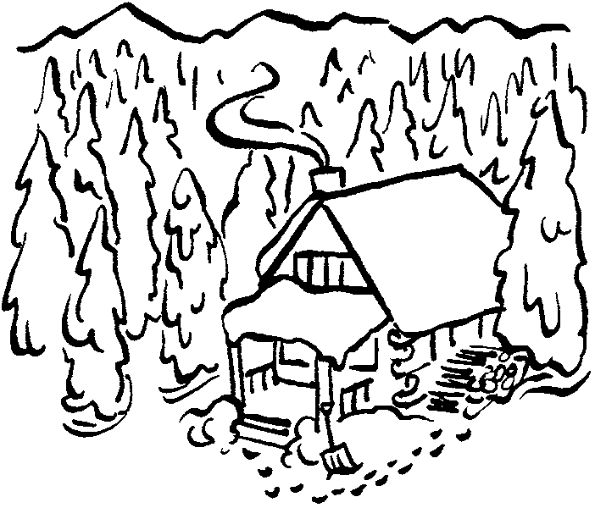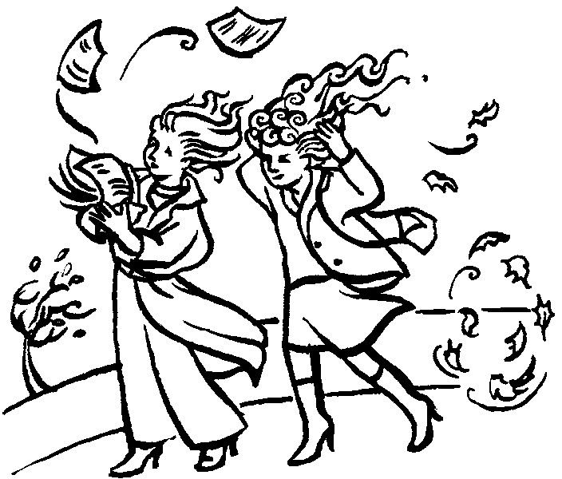
3. 4.
Paso 2. Choose two drawings from Paso 1 and write the season and a month associated with the weather depicted. Spelling counts!
1. Drawing: Season: Month:
2. Drawing: Season: Month:
C. Listen as your instructor reads a personality trait and choose the activity that best matches it.
1. a. tomar mucho café b. practicar un deporte c. leer
2. a. escuchar música b. hablar mucho por teléfono c. trabajar
3. a. leer novelas románticas b. correr c. practicar el fútbol
4. a. organizar los apuntes b. no pagar las cuentas (bills) c. comer mucho
5. a. tomar mucho el sol b. trabajar mucho c. estudiar poco
GRAMÁTICA
D. Choose from the following list of verbs for this activity.
asistir a clase beber comer correr escribir leer ver una película
Paso 1. Using two different verbs from the list, complete the sentences by writing about what you usually do in the following circumstances.
1. Los miércoles por la mañana
2. Cuando hace mucho frío
Paso 2. Look at sentence 2 from Paso 1 and write the question you would ask your instructor to find out whether he or she does the same thing you do.

Paso 3. What do you think your classmates (compañeros de clase) do?
Cuando hace mucho frío mis compañeros
E. Complete the sentences to describe what the following people are going to do this evening using a form of ir + a + infinitive. You must use a different infinitive for each sentence.
1. Mis amigos y yo .
2. Yo .
3. Mis compañeros de clase (classmates) .
4. Mi profesor(a) de español .
F. Use the following adjectives to complete this activity.
aburrido ambicioso cerebral divertido optimista
alegre arrogante conservador egoísta
1. Name a famous woman. Describe her using two personality traits from the list that you think best portray her.
es y .
2. Name two people (family members, friends, celebrities, and so forth) that you like or admire. Describe them using two adjectives from the list.
y son y .
SOL Y VIENTO
G. Answer the following questions based on the Prólogo and Episodio 1.
1. Match each character in the column on the left with the most appropriate description from the column on the right. Use each item only once.
1. Diego  2. Carlos  3. la machi  4. Mario  5. María  6. Jaime | a. chofer  b. empleado (employee) de Bartel Aquapower  c. viña «Sol y viento»  d. antropóloga  e. estudiante  f. líder espiritual
2. Según (Based on) lo que ves en la película:
a. ¿Qué tiempo hace en Chile?
b. ¿Qué estación del año crees que es?
3. ¿Con quién habla Jaime por teléfono?
a. con Bartel Aquapower b. con Mario c. con María d. con Carlos
CULTURA (Optativo)
H. Answer the following questions based on what you have learned in the Vistazos culturales sections.
1. Vosotros forms are used in to address “you all” in informal situations.
a. Latin America
b. Spain
c. Caribbean countries
2. If you would like to go to the running of the bulls in Pamplona (Spain), you would need to look for information on . . .
a. las fallas.
b. la fiesta de San Fermín.
c. la fiesta de San José.
3. The Spanish phrase no tener pelos en la lengua refers to people who . . .
a. are frank and outspoken.
b. worry about their appearance.
c. are somewhat guarded.
I. Answer the following based on what you have learned in the Panorama cultural section.
1. Chile es un país democrático. ¿Cierto o falso?
2. Chile tiene puertos (ports) en el océano Atlántico. ¿Cierto o falso?
3. Una banda famosa del en Chile es Los Bunkers.
a. jazz b. rock c. reggae
LECCIÓN 1B
Examen B (44 points)
VOCABULARIO
A. Listen as your instructor reads a series of questions. Answer them truthfully. Your answers need not be in complete sentences.
1.
2.
3.
4.
B. Listen as your instructor reads a statement about the weather. Select the activity most appropriate for that weather.
1. a. tomar el sol b. ver una película c. tomar un café en casa
2. a. correr b. escribir c. practicar el fútbol
3. a. beber limonada fría b. correr c. hablar por teléfono
4. a. abrir la puerta b. comer en el patio c. leer
C. Paso 1. Listen as your instructor names some American holidays. Write the month that is associated with each holiday. Spelling counts!
1. 2.
Paso 2. Write the season that is associated with each month you wrote in Paso 1. Spelling counts!
1. 2.
D. Listen as your instructor describes what a person does or likes to do. Then choose the personality trait that best fits that person.
1. a. caótica b. metódica c. tonta
2. a. triste b. tímida c. alegre
3. a. gregaria b. reservada c. pesimista
4. a. explosiva b. cerebral c. ingenua
GRAMÁTICA
E. Choose from the following list of verbs for this activity.
abrir la puerta asistir a clase beber correr escribir leer ver la televisión
Paso 1. Write about what you do. Complete the following sentences using two different verbs from the list.
1. Todos los días
2. Cada semana
Paso 2. Form a question to ask a classmate how frequently he or she does one of the activities you wrote about in Paso 1. Begin your question: ¿Con qué frecuencia... ?

F. Choose from the list of verbs in Activity E to complete the following sentences: (1) about you and your friends, and (2) about your classmates in Spanish class.
1. Todos los fines de semana mis amigos (friends) y yo
2. Los miércoles por la mañana mis compañeros (classmates)
G. Answer the following questions in Spanish about future summer plans. Your answers must be in complete sentences.
1. What are you going to do this coming summer?

2. What is your instructor going to do this summer? He or she will check the appropriate Sí/No box to let you know whether you guessed correctly.
sí  no 
H. Choose from the following adjectives to answer the questions in this section.
aburrido alegre chismoso egoísta optimista
agradable arrogante divertido leal
Paso 1. Name your best female friend. Describe her using two personality traits from the list.
Mi amiga es y
Paso 2. Name two well-known persons (for example, politicians, artists, sportspersons, and so forth) that you don’t particularly like or admire. Describe them using two adjectives from the list.
y son y
I. Complete the sentences to describe what the following people are going to do this evening using a form of ir + a + infinitive. You must use a different infinitive for each sentence.
1. Mis compañeros de clase (classmates) y yo .
2. Yo .
3. Mis amigos .
4. Mi profesor(a) de español .
SOL Y VIENTO
J. Answer the following questions based on the Prólogo and Episodio 1.
1. La machi es...
a. profesora.
b. una líder espiritual.
c. la dueña (owner) de «Sol y viento».
2. ¿Adónde va Jaime cuando llega al aeropuerto?
a. al Valle del Maipo
b. a su oficina
c. al Hotel Bonaparte
3. ¿Cuál es el apellido de Mario?
a. Verdejo
b. Talavera
c. Sánchez
4. ¿A qué hora van Jaime y Mario al Valle del Maipo?
a. a las 8:00 de la mañana
b. a las 10:00 de la mañana
c. a las 12:00 de la tarde
5. Jaime habla con Mario por teléfono. ¿Cierto o falso?
6. Jaime sabe de (knows about) vinos. ¿Cierto o falso?
CULTURA (Optativo)
K. Answer the following questions based on what you have learned in the Vistazos culturales sections.
1. When referring to “you all” in an informal situation, people in Latin America use . . .
a. ustedes b. vosotros c. tú
2. In Spanish-speaking countries there tend to be more public holidays than in this country. ¿Cierto o falso?
3. The expression no tener pelos en la lengua refers to people who . . .
a. worry about their appearance.
b. are somewhat guarded.
c. say what they are thinking.
d. are hardworking and brag about it.
L. Answer the following based on what you have learned in the Panorama cultural section.
1. En 2005 Augusto Pinochet fue elegido (was elected) presidente de Chile. ¿Cierto o falso?
2. Chile tiene un gran valle central. ¿Cierto o falso?
3. ¿Qué deportes son muy populares en Chile?
a. el fútbol y el esquí b. el fútbol y el béisbol
Prólogo y Episodio 1
Prueba (20 points)
A. Match each character with the most appropriate description on the right. Use each item only once.
1. Carlos  2. Diego  3. Jaime  4. la machi  5. María  6. Mario | a. antropóloga  b. empleado (employee) de Bartel Aquapower  c. administrador de «Sol y viento»  d. chofer  e. estudiante  f. líder espiritual
B. Answer each question based on what you saw in the movie.
1. ¿Qué tiempo hace en Chile?

2. ¿Qué estación del año crees que es?

C. Answer true (cierto) or false (falso).
cierto falso
1. Jaime desea ir a Chile.  
2. Jaime sabe de (knows about) vinos.  
3. Jaime se queda (is staying) en el Hotel Santiago.  
4. Jaime necesita hablar con Carlos.  
5. Andy dice que (says that) también va a viajar a Chile.  
D. Select the appropriate answer.
1. ¿Cómo se llama la cultura indígena de Chile?
a. Santiago
b. mapuche
c. machi
2. El apellido de Carlos es...
a. Talavera.
b. Verdejo.
c. Sánchez.
3. Jaime llama por teléfono a...
a. Bartel Aquapower.
b. Santiago.
c. la viña «Sol y viento».
4. Jaime y Mario piensan (are thinking about) ir al Valle del Maipo...
a. a las 10:00 de la mañana.
b. a las 8:00 de la mañana.
c. a la 1:00 de la tarde.
5. Mario dice que el Valle del Maipo es...
a. aburrido
b. lindo
c. agradable
E. Name two characters from the film. Describe them, using one adjective from the list.
agradable ambicioso/a bilingüe chileno/a trabajador(a)
y son .

