Organic Chemistry, 6e (Smith)
Chapter 1 Structure and Bonding

1) What is the ground-state electronic configuration of a carbon atom?
A) 1s2, 2s2, 2p5
B) 1s2, 2s2, 2p2
C) 1s2, 2s2, 2p6
D) 1s2, 2s2, 2p4

Answer: B
Difficulty: 1 Easy
Section: 01.01
Topic: Structure and Bonding
Bloom's: 2. Understand
Chapter: 01
Accessibility: Keyboard Navigation

2) What is the ground-state electronic configuration of a fluorine atom?
A) 1s2, 2s2, 2p2
B) 1s2, 2s2, 2p3
C) 1s2, 2s2, 2p4
D) 1s2, 2s2, 2p5

Answer: D
Difficulty: 1 Easy
Section: 01.01
Topic: Structure and Bonding
Bloom's: 2. Understand
Chapter: 01
Accessibility: Keyboard Navigation

3) What is the ground-state electronic configuration of a magnesium cation (Mg2+)?
A) 1s2, 2s2, 2p6
B) 1s2, 2s2, 2p6, 3s1
C) 1s2, 2s2, 2p6, 3s2
D) 1s2, 2s2, 2p6, 3s2, 3p2

Answer: A
Difficulty: 1 Easy
Section: 01.01
Topic: Structure and Bonding
Bloom's: 2. Understand
Chapter: 01
Accessibility: Keyboard Navigation

4) What is the ground-state electronic configuration of a chlorine anion (Cl—)?
A) 1s2, 2s2, 2p6
B) 1s2, 2s2, 2p6, 3s2, 3p6
C) 1s2, 2s2, 2p6, 3s2, 3p5
D) 1s2, 2s2, 2p6, 3s2, 3p4

Answer: B
Difficulty: 1 Easy
Section: 01.01
Topic: Structure and Bonding
Bloom's: 2. Understand
Chapter: 01
Accessibility: Keyboard Navigation

5) Which of the following statements about valence electrons is true?
A) They are the most tightly held electrons.
B) They do not participate in chemical reactions.
C) They are the outermost electrons.
D) They reveal the period number of a second-row element.

Answer: C
Difficulty: 1 Easy
Section: 01.01
Topic: Structure and Bonding
Bloom's: 2. Understand
Chapter: 01
Accessibility: Keyboard Navigation

6) Which of the following atoms will have a full 3s orbital in the ground state?
A) Hydrogen
B) Lithium
C) Potassium
D) Rubidium

Answer: D
Difficulty: 2 Medium
Section: 01.01
Topic: Structure and Bonding
Bloom's: 2. Understand
Chapter: 01
Accessibility: Keyboard Navigation

7) Which of the following statements about bonding is true?
A) Covalent bonds result from the transfer of electrons from one element to another.
B) Ionic bonds result from the transfer of electrons from a metal to a non-metal.
C) Ionic bonds result from the sharing of electrons between two non-metals.
D) Covalent bonds result from the sharing of electrons between two metals.

Answer: B
Difficulty: 1 Easy
Section: 01.02
Topic: Structure and Bonding
Bloom's: 1. Remember
Chapter: 01
Accessibility: Keyboard Navigation

8) Which of the following would you expect to have ionic bonds?
A) CO
B) FBr
C) NF3
D) NaCl

Answer: D
Difficulty: 1 Easy
Section: 01.02
Topic: Structure and Bonding
Bloom's: 3. Apply
Chapter: 01
Accessibility: Keyboard Navigation

9) Which of the following molecules has nonpolar covalent bonds?
A) HCl
B) N2
C) CHCl3
D) NO

Answer: B
Difficulty: 1 Easy
Section: 01.02
Topic: Structure and Bonding
Bloom's: 2. Understand
Chapter: 01
Accessibility: Keyboard Navigation

10) Which of the following molecules contain both covalent and ionic bonds?

A) I, II
B) I, IV
C) II, III
D) II, IV

Answer: D
Difficulty: 1 Easy
Section: 01.02
Topic: Structure and Bonding
Bloom's: 3. Apply
Chapter: 01

11) Which of the following would most likely form an ionic bond?

A) I
B) II
C) III
D) IV

Answer: D
Difficulty: 1 Easy
Section: 01.02
Topic: Structure and Bonding
Bloom's: 3. Apply
Chapter: 01

12) Which of the following statements correctly describes the typical number of bonds for carbon, nitrogen, and oxygen in most neutral organic molecules?
A) Carbon forms 4 covalent bonds, nitrogen forms 2 covalent bonds, and oxygen forms 3 covalent bonds.
B) Carbon forms 4 covalent bonds, nitrogen forms 3 covalent bonds, and oxygen forms 2 covalent bonds.
C) Carbon forms 4 covalent bonds, nitrogen forms 5 covalent bonds, and oxygen forms 2 covalent bonds.
D) Carbon forms 4 covalent bonds, nitrogen forms 5 covalent bonds, and oxygen forms 4 covalent bonds.

Answer: B
Difficulty: 1 Easy
Section: 01.02
Topic: Structure and Bonding
Bloom's: 1. Remember
Chapter: 01
Accessibility: Keyboard Navigation

13) Which is not an acceptable Lewis structure for the anion CH2NCO—?

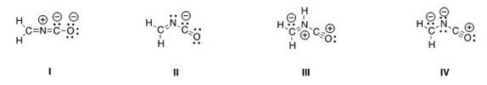

A) I
B) II
C) III
D) IV

Answer: C
Difficulty: 2 Medium
Section: 01.03
Topic: Structure and Bonding
Bloom's: 4. Analyze
Chapter: 01

14) Which of the following Lewis structures is correct?

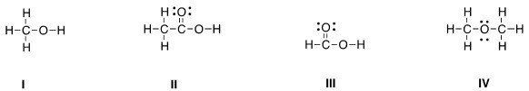

A) I
B) II
C) III
D) IV

Answer: D
Difficulty: 2 Medium
Section: 01.03
Topic: Structure and Bonding
Bloom's: 4. Analyze
Chapter: 01

15) Which of the following Lewis structures is correct?

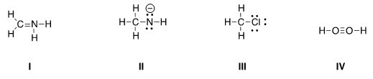

A) I, II
B) I, III
C) II, III
D) III, IV

Answer: C
Difficulty: 2 Medium
Section: 01.03
Topic: Structure and Bonding
Bloom's: 4. Analyze
Chapter: 01

16) Which is the correct Lewis structure for acetic acid (CH3CO2H)?

A) I
B) II
C) III
D) IV

Answer: D
Difficulty: 2 Medium
Section: 01.03
Topic: Structure and Bonding
Bloom's: 4. Analyze
Chapter: 01

17) In which of the following ions does carbon have a formal charge?

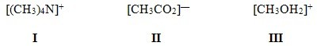

A) I
B) II
C) III
D) None of these

Answer: D
Difficulty: 1 Easy
Section: 01.03
Topic: Structure and Bonding
Bloom's: 1. Remember
Chapter: 01

18) In which of the following ions does carbon have a formal charge?

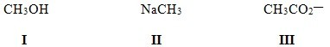

A) I
B) II
C) III
D) None of these

Answer: B
Difficulty: 1 Easy
Section: 01.03
Topic: Structure and Bonding
Bloom's: 1. Remember
Chapter: 01

19) What is the formal charge of carbon in carbon monoxide (CO) when drawn with a triple bond?
A) 0
B) -2
C) -1
D) +1

Answer: C
Difficulty: 2 Medium
Section: 01.03
Topic: Structure and Bonding
Bloom's: 4. Analyze
Chapter: 01
Accessibility: Keyboard Navigation

20) What is the formal charge of the carbon in carbon dioxide (CO2) when drawn with two double bonds?
A) +1
B) 0
C) -1
D) -2

Answer: B
Difficulty: 2 Medium
Section: 01.03
Topic: Structure and Bonding
Bloom's: 4. Analyze
Chapter: 01
Accessibility: Keyboard Navigation

21) Which of the following statements about constitutional isomers is true?
A) Constitutional isomers are different molecules having the different molecular formula.
B) Constitutional isomers are different molecules having the same molecular formula.
C) Constitutional isomers are same molecules having the different molecular formula.
D) Constitutional isomers are same molecules having the same molecular formula.

Answer: B
Difficulty: 1 Easy
Section: 01.04
Topic: Structure and Bonding
Bloom's: 1. Remember
Chapter: 01
Accessibility: Keyboard Navigation

22) How many constitutional isomers are there for a molecule having the molecular formula C2H6O?
A) 1
B) 2
C) 3
D) 4

Answer: B
Difficulty: 1 Easy
Section: 01.04
Topic: Structure and Bonding
Bloom's: 4. Analyze
Chapter: 01
Accessibility: Keyboard Navigation

23) How many constitutional isomers are there for a molecule having the molecular formula C3H8O?
A) 1
B) 2
C) 3
D) 4

Answer: C
Difficulty: 1 Easy
Section: 01.04
Topic: Structure and Bonding
Bloom's: 4. Analyze
Chapter: 01
Accessibility: Keyboard Navigation

24) How many constitutional isomers are there for a molecule having the molecular formula C3H6?
A) 1
B) 2
C) 3
D) 4

Answer: B
Difficulty: 1 Easy
Section: 01.04
Topic: Structure and Bonding
Bloom's: 4. Analyze
Chapter: 01
Accessibility: Keyboard Navigation

25) How many constitutional isomers are there for a molecule having the molecular formula C2H4Cl2?
A) 1
B) 2
C) 3
D) 4

Answer: B
Difficulty: 2 Medium
Section: 01.04
Topic: Structure and Bonding
Bloom's: 4. Analyze
Chapter: 01
Accessibility: Keyboard Navigation

26) How many different isomers are there for a compound having the molecular formula C3H6O?
A) 4
B) 5
C) 6
D) 7

Answer: D
Difficulty: 2 Medium
Section: 01.04
Topic: Structure and Bonding
Bloom's: 4. Analyze
Chapter: 01
Accessibility: Keyboard Navigation

27) Which of the following molecules are constitutional isomers?

A) I, II, IV
B) II, III, IV
C) I, III, IV
D) I, II, III

Answer: D
Difficulty: 1 Easy
Section: 01.04
Topic: Structure and Bonding
Bloom's: 4. Analyze
Chapter: 01

28) Which of the following compounds has an atom with an unfilled valence shell of electrons?
A) H2O
B) BCl3
C) CH4
D) CO2

Answer: B
Difficulty: 2 Medium
Section: 01.05
Topic: Structure and Bonding
Bloom's: 4. Analyze
Chapter: 01
Accessibility: Keyboard Navigation

29) Which of the following compounds has an atom with more than eight valence electrons?
A) H2CO3
B) H2SO4
C) H2O
D) HBr

Answer: B
Difficulty: 2 Medium
Section: 01.05
Topic: Structure and Bonding
Bloom's: 4. Analyze
Chapter: 01
Accessibility: Keyboard Navigation

30) How many electrons are around phosphorus in phosphoric acid (H3PO4)?
A) 6
B) 8
C) 10
D) 12

Answer: C
Difficulty: 2 Medium
Section: 01.05
Topic: Structure and Bonding
Bloom's: 4. Analyze
Chapter: 01
Accessibility: Keyboard Navigation

31) Which of the following statements about resonance structures is true?
A) Resonance structures have the same placement of electrons but different arrangement of atoms.
B) Resonance structures have the same placement of atoms but different arrangement of electrons.
C) Resonance structures have the same placement of atoms and the same arrangement of electrons.
D) Resonance structures have different placement of atoms and different arrangement of electrons.

Answer: B
Difficulty: 1 Easy
Section: 01.06
Topic: Structure and Bonding
Bloom's: 2. Understand
Chapter: 01
Accessibility: Keyboard Navigation

32) Which of the following statements about resonance structures is not true?
A) There is no movement of electrons from one form to another.
B) Resonance structures are not isomers.
C) Resonance structures differ only in the arrangement of electrons.
D) Resonance structures are in equilibrium with each other.

Answer: D
Difficulty: 1 Easy
Section: 01.06
Topic: Structure and Bonding
Bloom's: 2. Understand
Chapter: 01
Accessibility: Keyboard Navigation

33) Which of the following pair does not represent resonance structures?

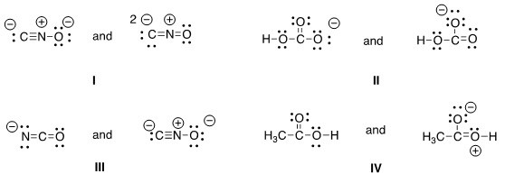
A) I
B) II
C) III
D) IV

Answer: C
Difficulty: 2 Medium
Section: 01.06
Topic: Structure and Bonding
Bloom's: 4. Analyze
Chapter: 01

34) What 2 things will change between two resonance structures?
A) The position of multiple bonds and non-bonded electrons.
B) The position of multiple bonds and single bonds.
C) The placement of atoms and single bonds.
D) The placement of atoms and non-bonded electrons.

Answer: A
Difficulty: 1 Easy
Section: 01.06
Topic: Structure and Bonding
Bloom's: 2. Understand
Chapter: 01
Accessibility: Keyboard Navigation

35) Which of the following is a resonance structure of the compound below?

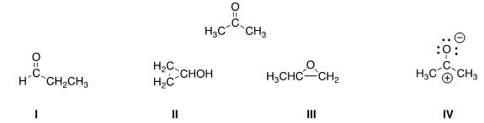

A) I
B) II
C) III
D) IV

Answer: D
Difficulty: 2 Medium
Section: 01.06
Topic: Structure and Bonding
Bloom's: 3. Apply
Chapter: 01

36) Which of the following resonance structures is the least important contributor to the resonance hybrid of the formate anion, HCOO—?

A) I
B) II
C) III
D) IV

Answer: B
Difficulty: 3 Hard
Section: 01.06
Topic: Structure and Bonding
Bloom's: 3. Apply
Chapter: 01

37) Rank the following in order of decreasing importance as contributing structures to the resonance hybrid of formaldehyde, H2CO.

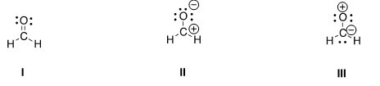

A) I > II > III
B) I > III > II
C) II > I > III
D) III > II > I

Answer: A
Difficulty: 3 Hard
Section: 01.06
Topic: Structure and Bonding
Bloom's: 3. Apply
Chapter: 01

38) Follow the curved arrows to draw the second resonance structure for the ion below.

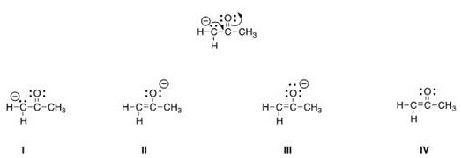

A) I
B) II
C) III
D) IV

Answer: C
Difficulty: 2 Medium
Section: 01.06
Topic: Structure and Bonding
Bloom's: 2. Understand
Chapter: 01

39) Which is more important in each pair of contributing resonance structures?

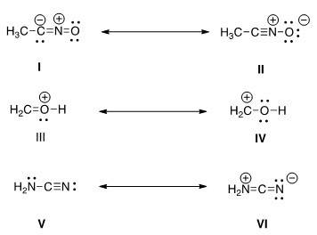

A) II, IV, V
B) II, III, V
C) II, III, VI
D) I, IV, V

Answer: B
Difficulty: 2 Medium
Section: 01.06
Topic: Structure and Bonding
Bloom's: 4. Analyze
Chapter: 01

40) What is the approximate value of the H-C-H bond angle in methane, CH4?
A) 90°
B) 109.5°
C) 120°
D) 180°

Answer: B
Difficulty: 1 Easy
Section: 01.07
Topic: Molecular Shape
Bloom's: 1. Remember
Chapter: 01
Accessibility: Keyboard Navigation

41) What is the approximate C-C-C bond angle in propene, CH3CH = CH2?
A) 90°
B) 109.5°
C) 120°
D) 180°

Answer: C
Difficulty: 1 Easy
Section: 01.07
Topic: Molecular Shape
Bloom's: 2. Understand
Chapter: 01
Accessibility: Keyboard Navigation

42) What is the approximate H-C-O bond angle in formaldehyde, H2CO?
A) 90°
B) 109.5°
C) 120°
D) 180°

Answer: C
Difficulty: 2 Medium
Section: 01.07
Topic: Molecular Shape
Bloom's: 2. Understand
Chapter: 01
Accessibility: Keyboard Navigation

43) Determine the geometry around the indicated atom in each species.

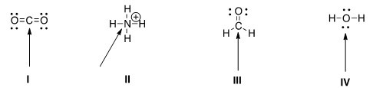

A) I = Linear; II = tetrahedral; III = trigonal planar; IV = tetrahedral
B) I = Linear; II = tetrahedral; III = trigonal planar; IV = linear
C) I = Trigonal planar; II = linear; III = tetrahedral; IV = trigonal planar
D) I = Tetrahedral; II = trigonal planar; III = linear; IV = tetrahedral

Answer: A
Difficulty: 1 Easy
Section: 01.07
Topic: Molecular Shape
Bloom's: 1. Remember
Chapter: 01

44) What is the approximate bond angle for the C-C-N bond in acetonitrile, CH3CN?
A) 90°
B) 109.5°
C) 120°
D) 180°

Answer: D
Difficulty: 2 Medium
Section: 01.07
Topic: Molecular Shape
Bloom's: 4. Analyze
Chapter: 01
Accessibility: Keyboard Navigation

45) What is the molecular geometry around the boron atom in BH3?
A) Tetrahedral
B) Trigonal Planar
C) Trigonal Pyramidal
D) Linear

Answer: B
Difficulty: 2 Medium
Section: 01.07
Topic: Molecular Shape
Bloom's: 4. Analyze
Chapter: 01
Accessibility: Keyboard Navigation

46) What is the molecular geometry around the carbon atom in CH4?
A) Tetrahedral
B) Trigonal Planar
C) Trigonal Pyramidal
D) Linear

Answer: A
Difficulty: 2 Medium
Section: 01.07
Topic: Molecular Shape
Bloom's: 4. Analyze
Chapter: 01
Accessibility: Keyboard Navigation

47) Which of the following is the appropriate conversion of the condensed structure, CH3COCH3, to a Lewis structure?

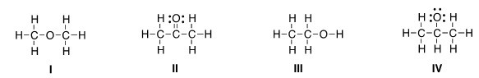

A) I
B) II
C) III
D) IV

Answer: B
Difficulty: 2 Medium
Section: 01.08
Topic: Drawing Organic Molecules
Bloom's: 2. Understand
Chapter: 01

48) Which of the following is the appropriate conversion of (CH3)2CHCH2CHClCH3 to a skeletal structure?

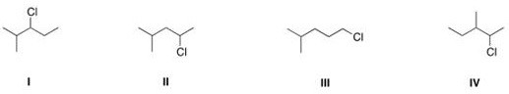

A) I
B) II
C) III
D) IV

Answer: B
Difficulty: 2 Medium
Section: 01.08
Topic: Drawing Organic Molecules
Bloom's: 2. Understand
Chapter: 01

49) Which of the following is the appropriate conversion of (CH3)4C to a skeletal structure?

A) I
B) II
C) III
D) IV

Answer: D
Difficulty: 1 Easy
Section: 01.08
Topic: Drawing Organic Molecules
Bloom's: 2. Understand
Chapter: 01

50) What is the condensed formula of the compound below?

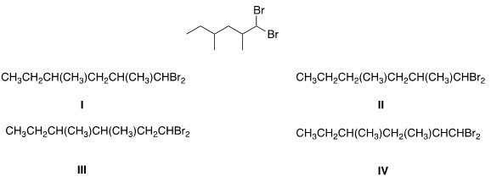

A) I
B) II
C) III
D) IV

Answer: A
Difficulty: 2 Medium
Section: 01.08
Topic: Drawing Organic Molecules
Bloom's: 2. Understand
Chapter: 01

51) Which of the following is the appropriate conversion of (CH3)2CHOCH2CH2CH2OH to a skeletal structure?

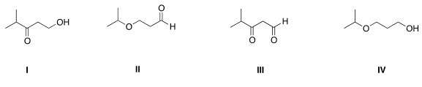
A) I
B) II
C) III
D) IV

Answer: D
Difficulty: 2 Medium
Section: 01.08
Topic: Drawing Organic Molecules
Bloom's: 2. Understand
Chapter: 01

52) Convert the following skeletal structure to a condensed structure.

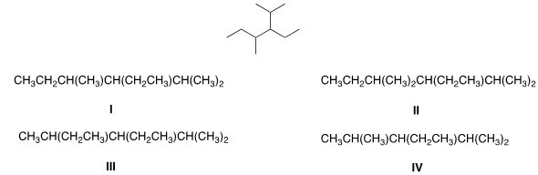
A) I
B) II
C) III
D) IV

Answer: A
Difficulty: 2 Medium
Section: 01.08
Topic: Drawing Organic Molecules
Bloom's: 2. Understand
Chapter: 01

53) Avobenzone is an active ingredient in some common sunscreens. Which of the following is the correct molecular formula for avobenzone?

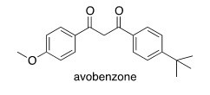

A) C22O22O3
B) C20H22O3
C) C21H23O3
D) C20H24O3

Answer: B
Difficulty: 2 Medium
Section: 01.08
Topic: Drawing Organic Molecules
Bloom's: 3. Apply
Chapter: 01

54) In which structure is the hybridization incorrect?

A) I
B) II
C) III
D) IV

Answer: B
Difficulty: 2 Medium
Section: 01.09
Topic: Molecular Shape
Bloom's: 2. Understand
Chapter: 01

55) What is the hybridization for each of the indicated atoms in the following compound?

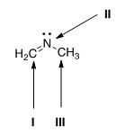

A) I = sp2; II = sp2; III = sp2.
B) I = sp2; II = sp3; III = sp3.
C) I = sp; II = sp2; III = sp3.
D) I = sp2; II = sp2; III = sp3.

Answer: D
Difficulty: 2 Medium
Section: 01.09
Topic: Molecular Shape
Bloom's: 2. Understand
Chapter: 01

56) What is the hybridization of the carbon atom in the methyl cation, (CH3+)?
A) sp3
B) sp2
C) sp
D) p

Answer: B
Difficulty: 2 Medium
Section: 01.09
Topic: Molecular Shape
Bloom's: 2. Understand
Chapter: 01
Accessibility: Keyboard Navigation

57) What is the hybridization of the nitrogen atom in the ammonium cation, NH4+?
A) sp3
B) sp2
C) sp
D) p

Answer: A
Difficulty: 2 Medium
Section: 01.09
Topic: Molecular Shape
Bloom's: 2. Understand
Chapter: 01
Accessibility: Keyboard Navigation

58) Which atomic orbitals overlap to form the C-H s bonding molecular orbitals of ethane, CH3CH3?
A) Csp2 + H1s
B) Csp3 + H1s
C) C2p + H1s
D) Csp + H1s

Answer: B
Difficulty: 2 Medium
Section: 01.10
Topic: Molecular Shape
Bloom's: 3. Apply
Chapter: 01
Accessibility: Keyboard Navigation

59) Which atomic orbitals overlap to form the C-H s bonding molecular orbitals of ethylene, H2C=CH2?
A) C2p + H1s
B) Csp + H1s
C) Csp3 + H1s
D) Csp2 + H1s

Answer: D
Difficulty: 2 Medium
Section: 01.10
Topic: Molecular Shape
Bloom's: 3. Apply
Chapter: 01
Accessibility: Keyboard Navigation

60) Which atomic orbitals overlap to form the carbon-carbon s and p bonding molecular orbitals of ethylene, H2C=CH2?
A) Csp3 + Csp3, and C2p + C2p
B) Csp3 + Csp3, and Csp2 + Csp2
C) Csp2 + Csp2, and C2p + C2p
D) Csp2 + Csp2, and Csp2 + Csp2

Answer: C
Difficulty: 2 Medium
Section: 01.10
Topic: Molecular Shape
Bloom's: 3. Apply
Chapter: 01
Accessibility: Keyboard Navigation

61) Which atomic orbitals overlap to form the C-H s bonding molecular orbitals of acetylene, C2H2?
A) Csp + H1s
B) C2p +H1s
C) Csp3 + H1s
D) Csp2 + H1s

Answer: A
Difficulty: 2 Medium
Section: 01.10
Topic: Molecular Shape
Bloom's: 3. Apply
Chapter: 01
Accessibility: Keyboard Navigation

62) Which atomic orbitals overlap to form the carbon-carbon s bonding molecular orbital of acetylene, C2H2?
A) Csp2 + Csp2
B) Csp + Csp
C) Csp3 + Csp3
D) C2p + C2p

Answer: B
Difficulty: 2 Medium
Section: 01.10
Topic: Molecular Shape
Bloom's: 3. Apply
Chapter: 01
Accessibility: Keyboard Navigation

63) When forming molecular orbitals from atomic orbitals, what is the order of increasing C-H bond strength for the following set?

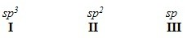

A) II < I < III
B) III < I < II
C) III < II < I
D) I < II < III

Answer: D
Difficulty: 2 Medium
Section: 01.11
Topic: Molecular Shape
Bloom's: 3. Apply
Chapter: 01

64) What is the order of decreasing bond length for a C-C bond composed of the following molecular orbitals?

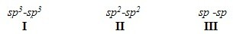

A) I > III > II
B) I > II > III
C) III > II > I
D) II > III > I

Answer: B
Difficulty: 2 Medium
Section: 01.11
Topic: Molecular Shape
Bloom's: 3. Apply
Chapter: 01

65) Which of the following statements about electronegativity and the periodic table is true?
A) Electronegativity decreases across a row of the periodic table.
B) Electronegativity increases down a column of the periodic table.
C) Electronegativity increases across a row of the periodic table.
D) Electronegativity does not change down a column of the periodic table.

Answer: C
Difficulty: 2 Medium
Section: 01.12
Topic: Molecular Shape
Bloom's: 2. Understand
Chapter: 01
Accessibility: Keyboard Navigation

66) Rank the following atoms in order of increasing electronegativity, putting the least electronegative first.

A) I < II < III < IV
B) I < IV < II < III
C) III < II < IV < I
D) I < II < IV < III

Answer: B
Difficulty: 2 Medium
Section: 01.12
Topic: Molecular Shape
Bloom's: 3. Apply
Chapter: 01

67) Rank the following atoms in order of decreasing electronegativity, putting the most electronegative first.

A) I > IV > II > III
B) II > III > IV > I
C) III > IV > II > I
D) III > II > IV > I

Answer: D
Difficulty: 2 Medium
Section: 01.12
Topic: Molecular Shape
Bloom's: 3. Apply
Chapter: 01

68) Which molecule has the greatest difference in electronegativity (DE) between the two different elements?
A) CO2
B) H2S
C) NH3
D) H2O

Answer: D
Difficulty: 2 Medium
Section: 01.12
Topic: Molecular Shape
Bloom's: 3. Apply
Chapter: 01
Accessibility: Keyboard Navigation

69) Which compound contains the most polar bond?

A) I
B) II
C) III
D) IV

Answer: B
Difficulty: 2 Medium
Section: 01.12
Topic: Molecular Shape
Bloom's: 3. Apply
Chapter: 01

70) Which of the following compounds are non-polar?

A) I, IV
B) I, II
C) II, III
D) II, IV

Answer: A
Difficulty: 2 Medium
Section: 01.13
Topic: Molecular Shape
Bloom's: 3. Apply
Chapter: 01

71) Which of the following molecules has non-polar covalent bonds?
A) CO2
B) N2
C) CCl4
D) HF

Answer: B
Difficulty: 2 Medium
Section: 01.12
Topic: Molecular Shape
Bloom's: 2. Understand
Chapter: 01
Accessibility: Keyboard Navigation

72) Which of the following molecules has polar covalent bonds?
A) MgO
B) NH3
C) Cl2
D) NaBr

Answer: B
Difficulty: 2 Medium
Section: 01.12
Topic: Molecular Shape
Bloom's: 2. Understand
Chapter: 01
Accessibility: Keyboard Navigation

73) Which of the following covalent bonds has the largest dipole moment?
A) C-H
B) C-C
C) C-O
D) H-F

Answer: D
Difficulty: 2 Medium
Section: 01.12
Topic: Molecular Shape
Bloom's: 3. Apply
Chapter: 01
Accessibility: Keyboard Navigation

74) Which of the following molecules has the smallest dipole moment?
A) CO2
B) HCl
C) H2O
D) NH3

Answer: A
Difficulty: 2 Medium
Section: 01.12
Topic: Molecular Shape
Bloom's: 2. Understand
Chapter: 01
Accessibility: Keyboard Navigation

75) Which of the following molecules does not have a net dipole moment of zero?
A) CCl4
B) BF3
C) CO2
D) NH3

Answer: D
Difficulty: 2 Medium
Section: 01.13
Topic: Molecular Shape
Bloom's: 2. Understand
Chapter: 01
Accessibility: Keyboard Navigation

76) Which of the following molecules has a net dipole moment of zero?

A) I
B) II
C) III
D) IV

Answer: B
Difficulty: 2 Medium
Section: 01.13
Topic: Molecular Shape
Bloom's: 4. Analyze
Chapter: 01

77) Consider compounds which contain both a heteroatom and a double bond. For which compound is no additional Lewis structure possible?

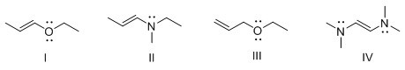

A) I
B) II
C) III
D) IV

Answer: C
Difficulty: 3 Hard
Section: 01.06
Topic: Structure and Bonding
Bloom's: 4. Analyze
Chapter: 01

