Organic Chemistry, 11e (Carey)
Chapter 1 Structure Determines Properties

1) What is the ground state electron configuration of carbon?
A) 1s22s22px1
B) 1s22s22px2
C) 1s22s22px12py1
D) 1s22s22px22py1

Answer: C
Difficulty: 2 Medium
Section: 01.01
Topic: Structure and Bonding
Bloom's: 3. Apply
Chapter: 01
Subtopic: Periodic table trends

2) Which of the following has (have) the same electron configuration as Ne?

Na− Mg2+ O2− Mg+
A) Na− and O2−
B) Mg2+ and O2−
C) Mg+ and O2−
D) only Mg2+

Answer: B
Difficulty: 2 Medium
Section: 01.02
Topic: Structure and Bonding
Bloom's: 4. Analyze
Chapter: 01
Subtopic: Periodic table trends

3) What is the letter designation given to dumbbell shaped orbitals like the one depicted below?
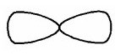
A) s
B) p
C) d
D) f

Answer: B
Difficulty: 1 Easy
Section: 01.01
Topic: Molecular Shape
Bloom's: 1. Remember
Chapter: 01
Subtopic: Atomic orbitals

4) Predict which bond is the most polar in ethanol, CH3CH2OH.
A) C-C
B) C-H
C) C-O
D) O-H

Answer: D
Difficulty: 2 Medium
Section: 01.04
Topic: Structure and Bonding
Bloom's: 4. Analyze
Chapter: 01
Subtopic: Types of bonds; Bond properties

5) What can be said about the polarity of the C=O bond?
A) C and O have the same electronegativity; the bond is nonpolar
B) the C=O bond is polar; the O atom bears a partial negative charge
C) the C=O bond is nonpolar; the C atom bears a partial positive charge
D) the C=O bond is polar; the C atom bears a partial negative charge

Answer: B
Difficulty: 2 Medium
Section: 01.04
Topic: Structure and Bonding
Bloom's: 2. Understand
Chapter: 01
Subtopic: Types of bonds; Bond properties

6) In which of the following compounds would you expect Cl to have a partial positive charge?
A) HCl
B) CCl4
C) NaCl
D) HOCl

Answer: D
Difficulty: 2 Medium
Section: 01.04
Topic: Structure and Bonding
Bloom's: 2. Understand
Chapter: 01
Subtopic: Types of bonds; Bond properties

7) In which of the following does hydrogen have a partial negative charge based on electronegativity?
A) BH3
B) CH4
C) NH3
D) H2O

Answer: A
Difficulty: 2 Medium
Section: 01.04
Topic: Structure and Bonding
Bloom's: 2. Understand
Chapter: 01
Subtopic: Types of bonds; Bond properties

8) What is the formal charge on the carbon atom?

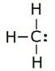
A) +1
B) 0
C) −1
D) −2

Answer: C
Difficulty: 2 Medium
Section: 01.05
Topic: Structure and Bonding
Bloom's: 3. Apply
Chapter: 01
Subtopic: Formal charges

9) What is the formal charge on the oxygen atom in the structure below?

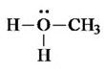
A) −1
B) 0
C) +1
D) +2

Answer: C
Difficulty: 2 Medium
Section: 01.05
Topic: Structure and Bonding
Bloom's: 3. Apply
Chapter: 01
Subtopic: Formal charges

10) What is the formal charge on the nitrogen atom in the structure below?

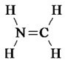
A) −1
B) 0
C) +1
D) +2

Answer: C
Difficulty: 2 Medium
Section: 01.05
Topic: Structure and Bonding
Bloom's: 3. Apply
Chapter: 01
Subtopic: Formal charges

11) The formal charges on the nitrogen and oxygen in the following structures are, respectively

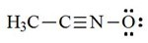
A) +1, −1
B) 0, −1
C) +1, 0
D) 0, 0

Answer: A
Difficulty: 2 Medium
Section: 01.05
Topic: Structure and Bonding
Bloom's: 3. Apply
Chapter: 01
Subtopic: Formal charges

12) What are the formal charges of boron and nitrogen, respectively, in the following structure?

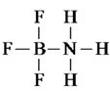
A) −1 and +1
B) −1 and 0
C) 0 and +1
D) 0 and 0

Answer: A
Difficulty: 2 Medium
Section: 01.05
Topic: Structure and Bonding
Bloom's: 3. Apply
Chapter: 01
Subtopic: Formal charges

13) Which of the following species have a zero formal charge on its carbon atom?

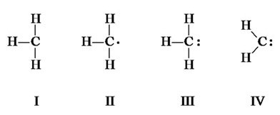
A) I and II
B) II and IV
C) III and IV
D) I, II, and III

Answer: B
Difficulty: 2 Medium
Section: 01.05
Topic: Structure and Bonding
Bloom's: 3. Apply
Chapter: 01
Subtopic: Formal charges

14) A Lewis structure of the azide ion, N3¯, is shown below. The formal charge on the middle nitrogen atom is

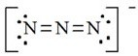
A) +2
B) +1
C) 0
D) −1

Answer: B
Difficulty: 2 Medium
Section: 01.05
Topic: Structure and Bonding
Bloom's: 3. Apply
Chapter: 01
Subtopic: Formal charges

15) What atom would have a formal charge in this structure?
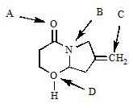
A) A
B) B
C) C
D) D

Answer: D
Difficulty: 2 Medium
Section: 01.05
Topic: Structure and Bonding
Bloom's: 2. Understand
Chapter: 01
Subtopic: Formal charges

16) Identify the condensed formula of the following structure

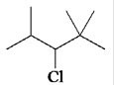

A) (CH3)2CHCHClCH(CH3)2
B) CH3CH(CH3)CHClCH(CH3)2
C) (CH3)2CHCHClC(CH3)3
D) (CH3)3CCHClCH(CH3)3

Answer: C
Difficulty: 2 Medium
Section: 01.06
Topic: Drawing Organic Molecules
Bloom's: 3. Apply
Chapter: 01
Subtopic: Skeletal/bond-line structures; Condensed formula

17) What is the chemical formula of the following carbon skeleton diagram?

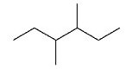
A) C8H14
B) C8H16
C) C8H18
D) C8H20

Answer: C
Difficulty: 1 Easy
Section: 01.06
Topic: Drawing Organic Molecules
Bloom's: 2. Understand
Chapter: 01
Subtopic: Skeletal/bond-line structures

18) Give the molecular formula of the compound shown below

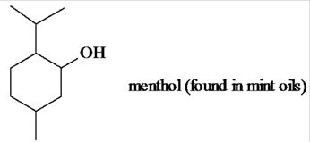
A) C8H16O
B) C9H18O
C) C10H18O
D) C10H20O

Answer: D
Difficulty: 2 Medium
Section: 01.06
Topic: Drawing Organic Molecules
Bloom's: 2. Understand
Chapter: 01
Subtopic: Skeletal/bond-line structures

19) How many hydrogen atoms are there on carbon atoms 1 and 2, respectively, in the structure below?

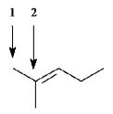
A) 4, 1
B) 4, 0
C) 3, 1
D) 3, 0

Answer: D
Difficulty: 2 Medium
Section: 01.06
Topic: Drawing Organic Molecules
Bloom's: 2. Understand
Chapter: 01
Subtopic: Skeletal/bond-line structures

20) How many C3H8O constitutional isomers are possible?
A) one
B) two
C) three
D) four

Answer: C
Difficulty: 2 Medium
Section: 01.06
Topic: Drawing Organic Molecules
Bloom's: 3. Apply
Chapter: 01
Subtopic: Constitutional isomers

21) Which of the following best describes the relationship between the two structures?

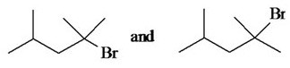
A) identical compounds
B) resonance structures
C) constitutional isomers
D) different compounds with different constitutions

Answer: A
Difficulty: 2 Medium
Section: 01.06
Topic: Drawing Organic Molecules
Bloom's: 2. Understand
Chapter: 01
Subtopic: Skeletal/bond-line structures

22) How many constitutional isomers of C4H9Br are possible?
A) one
B) two
C) three
D) four

Answer: D
Difficulty: 2 Medium
Section: 01.06
Topic: Drawing Organic Molecules
Bloom's: 3. Apply
Chapter: 01
Subtopic: Constitutional isomers

23) How many constitutional isomers of C3H6Cl2 are possible?
A) three
B) four
C) five
D) six

Answer: B
Difficulty: 2 Medium
Section: 01.06
Topic: Drawing Organic Molecules
Bloom's: 3. Apply
Chapter: 01
Subtopic: Constitutional isomers

24) Which of the following describes the relationship between the following two structures?

A) identical structures
B) resonance forms
C) constitutional isomers
D) different compounds with different compositions

Answer: A
Difficulty: 2 Medium
Section: 01.06
Topic: Drawing Organic Molecules
Bloom's: 2. Understand
Chapter: 01
Subtopic: Skeletal/bond-line structures

25) What is the molecular formula of aspirin?

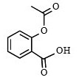
A) C6H4O4
B) C8H8O4
C) C9H8O4
D) C9H10O4

Answer: C
Difficulty: 2 Medium
Section: 01.06
Topic: Drawing Organic Molecules
Bloom's: 2. Understand
Chapter: 01
Subtopic: Skeletal/bond-line structures

26) Which of the following is not identical to the others?

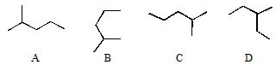
A) A
B) B
C) C
D) D

Answer: D
Difficulty: 1 Easy
Section: 01.06
Topic: Drawing Organic Molecules
Bloom's: 2. Understand
Chapter: 01
Subtopic: Skeletal/bond-line structures

27) Which of the line-bond structures below cannot represent a stable molecule?

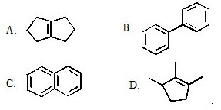
A) A
B) B
C) C
D) D

Answer: C
Difficulty: 2 Medium
Section: 01.06
Topic: Drawing Organic Molecules
Bloom's: 2. Understand
Chapter: 01
Subtopic: Skeletal/bond-line structures

28) What would be the line-bond structure for (CH3)3CCH2CH(CH3)2?

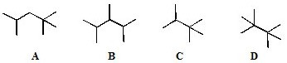
A) A
B) B
C) C
D) D

Answer: A
Difficulty: 2 Medium
Section: 01.06
Topic: Drawing Organic Molecules
Bloom's: 2. Understand
Chapter: 01
Subtopic: Skeletal/bond-line structures; Condensed formula

29) Which of the following describes the relationship between the following two ions?

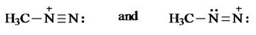
A) identical structures
B) resonance forms
C) constitutional isomers
D) different compounds with different compositions

Answer: B
Difficulty: 1 Easy
Section: 01.07
Topic: Structure and Bonding
Bloom's: 2. Understand
Chapter: 01
Subtopic: Resonance

30) The most stable resonance contributor of this would be:

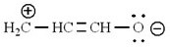

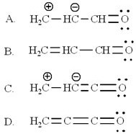
A) A
B) B
C) C
D) D

Answer: B
Difficulty: 2 Medium
Section: 01.07
Topic: Structure and Bonding
Bloom's: 4. Analyze
Chapter: 01
Subtopic: Resonance

31) Which of the electron-movement arrows below are NOT valid?

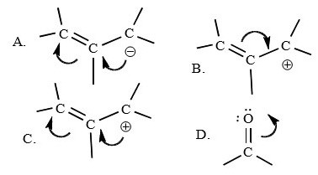
A) A
B) B
C) C
D) D

Answer: C
Difficulty: 2 Medium
Section: 01.07
Topic: Structure and Bonding
Bloom's: 2. Understand
Chapter: 01
Subtopic: Resonance

32) The electron pair movement depicted below produces a second resonance form for the species. What is the formal charge on the nitrogen atom for this second resonance form?

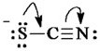
A) −2
B) −1
C) 0
D) +1

Answer: B
Difficulty: 3 Hard
Section: 01.07
Topic: Structure and Bonding; Curved Arrows
Bloom's: 3. Apply
Chapter: 01
Subtopic: Formal charges; Resonance; Bond formation and bond breaking; Drawing and interpretation

33) Identify the resonance structure that results from the following "electron pair movements."

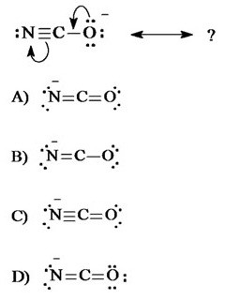
A) A
B) B
C) C
D) D

Answer: A
Difficulty: 2 Medium
Section: 01.07
Topic: Structure and Bonding
Bloom's: 3. Apply
Chapter: 01
Subtopic: Resonance

34) Which of the following atoms has vacant d orbitals that permit it to accommodate more than eight electrons in its valence shell?
A) N
B) C
C) Ne
D) S

Answer: D
Difficulty: 1 Easy
Section: 01.08
Topic: Structure and Bonding
Bloom's: 2. Understand
Chapter: 01
Subtopic: Octet rule exceptions

35) Based on the VSEPR model, which of the following species has (have) a trigonal planar geometry?

I. BCl3 II. NH3 III. NO3¯
A) only I
B) I and II
C) I and III
D) I, II, and III

Answer: C
Difficulty: 3 Hard
Section: 01.09
Topic: Molecular Shape
Bloom's: 3. Apply
Chapter: 01
Subtopic: VSEPR theory

36) Based on VSEPR theory, which of the following species has (have) a trigonal pyramidal geometry?

I. CO32− II. NH3 III. CH3+
A) only I
B) only II
C) I and II
D) II and III

Answer: B
Difficulty: 3 Hard
Section: 01.09
Topic: Molecular Shape
Bloom's: 3. Apply
Chapter: 01
Subtopic: VSEPR theory

37) Which of the following species has(have) a linear geometry?

I. CO2 II. NO2 + III. NO2¯
A) only I
B) only II
C) I and II
D) I, II, and III

Answer: C
Difficulty: 3 Hard
Section: 01.09
Topic: Molecular Shape
Bloom's: 3. Apply
Chapter: 01
Subtopic: VSEPR theory

38) The H-C-H bond angles in ethylene, C2H4, are closest to
A) 90°.
B) 109.5°.
C) 120°.
D) 180°.

Answer: C
Difficulty: 2 Medium
Section: 01.09
Topic: Molecular Shape
Bloom's: 2. Understand
Chapter: 01
Subtopic: Hybridization

39) The C-C-C bond angle in propane, C3H8, is closest to
A) 90°.
B) 109.5°.
C) 120°.
D) 180°.

Answer: B
Difficulty: 2 Medium
Section: 01.09
Topic: Molecular Shape
Bloom's: 2. Understand
Chapter: 01
Subtopic: Hybridization

40) Which statement correctly describes the structures of BH3 and NH3?
A) Both are trigonal and planar.
B) Both are pyramidal.
C) BH3 is trigonal planar and NH3 is trigonal pyramidal.
D) BH3 is trigonal pyramidal and NH3 is trigonal planar.

Answer: C
Difficulty: 3 Hard
Section: 01.09
Topic: Molecular Shape
Bloom's: 3. Apply
Chapter: 01
Subtopic: VSEPR theory

41) Which of the following molecules would you expect to have a dipole moment?

I. CO2 II. HCN III. CHCl3
A) II and III
B) only II
C) only III
D) I, II, and III

Answer: A
Difficulty: 3 Hard
Section: 01.10
Topic: Molecular Shape
Bloom's: 4. Analyze
Chapter: 01
Subtopic: Dipole moments; Polarity of molecules

42) Which of the following molecules would you expect to have a dipole moment?

I. CH2Cl2 II. CH3Cl III. CCl4
A) only I
B) only II
C) I and II
D) I, II, and III

Answer: C
Difficulty: 3 Hard
Section: 01.10
Topic: Molecular Shape
Bloom's: 4. Analyze
Chapter: 01
Subtopic: Dipole moments; Polarity of molecules

43) Which one of the following is isoelectronic with CO2?
A) NO2¯
B) NO2+
C) NO2
D) O3

Answer: B
Difficulty: 3 Hard
Section: 01.10
Topic: Molecular Shape
Bloom's: 4. Analyze
Chapter: 01
Subtopic: VSEPR theory; Dipole moments; Polarity of molecules

44) Which one of the following species is formed when diazomethane loses a nitrogen molecule?

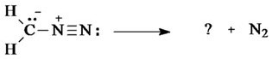

diazomethane
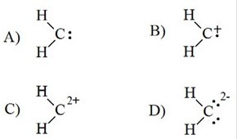
A) A
B) B
C) C
D) D

Answer: A
Difficulty: 3 Hard
Section: 01.11
Topic: Curved Arrows
Bloom's: 3. Apply
Chapter: 01
Subtopic: Bond formation and bond breaking; Drawing and interpretation

45) Which species is formed when the CH3N2+ cation loses a nitrogen molecule?
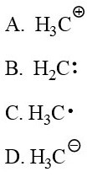
A) A
B) B
C) C
D) D

Answer: A
Difficulty: 3 Hard
Section: 01.11
Topic: Curved Arrows
Bloom's: 3. Apply
Chapter: 01
Subtopic: Bond formation and bond breaking; Drawing and interpretation

46) Which one of the following mechanistically depicts the protonation of methanol by hydrogen bromide?
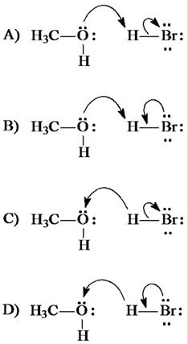
A) A
B) B
C) C
D) D

Answer: A
Difficulty: 2 Medium
Section: 01.11
Topic: Curved Arrows
Bloom's: 2. Understand
Chapter: 01
Subtopic: Curved arrow notation

47) Identify the species that results from the following movement of electron pairs.

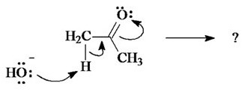

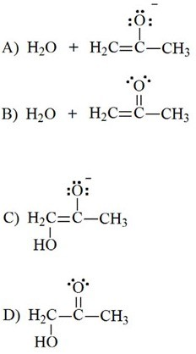
A) A
B) B
C) C
D) D

Answer: A
Difficulty: 3 Hard
Section: 01.11
Topic: Curved Arrows
Bloom's: 3. Apply
Chapter: 01
Subtopic: Bond formation and bond breaking; Drawing and interpretation; Curved arrow notation

48) What structure would result from these electron movement arrows?

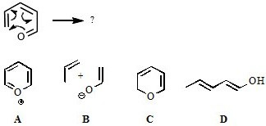
A) A
B) B
C) C
D) D

Answer: C
Difficulty: 2 Medium
Section: 01.11
Topic: Curved Arrows
Bloom's: 3. Apply
Chapter: 01
Subtopic: Bond formation and bond breaking; Drawing and interpretation; Curved arrow notation

49) Which one of the following is the conjugate base of NH3?
A) NH4+
B) H+
C) N3−
D) NH2−

Answer: D
Difficulty: 2 Medium
Section: 01.12
Topic: Acids and Bases
Bloom's: 3. Apply
Chapter: 01
Subtopic: Acid/Base definitions

50) Which one of the following is the conjugate acid of ethanol?
A) CH3CH2O−
B) CH3CH2O+
C) CH3CH2OH2+
D) CH3CH2OH3+

Answer: C
Difficulty: 2 Medium
Section: 01.12
Topic: Acids and Bases
Bloom's: 2. Understand
Chapter: 01
Subtopic: Acid/Base definitions

51) Which one of the following is the strongest base?
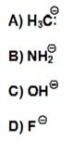
A) A
B) B
C) C
D) D

Answer: A
Difficulty: 2 Medium
Section: 01.13
Topic: Acids and Bases
Bloom's: 2. Understand
Chapter: 01
Subtopic: Factors affecting acid strength

52) Which one of the following is the strongest acid?
A) FCH2CO2H
B) ClCH2CO2H
C) BrCH2CO2H
D) ICH2CO2H

Answer: A
Difficulty: 3 Hard
Section: 01.13
Topic: Acids and Bases
Bloom's: 4. Analyze
Chapter: 01
Subtopic: Factors affecting acid strength

53) Which one of the following has the largest acid equilibrium constant, Ka?
A) CH3CO2H
B) CH2ClCO2H
C) CHCl2CO2H
D) CCl3CO2H

Answer: D
Difficulty: 3 Hard
Section: 01.13
Topic: Acids and Bases
Bloom's: 4. Analyze
Chapter: 01
Subtopic: Factors affecting acid strength; pKa

54) In the equilibrium below, the strongest base is (pKa H2O = 15.7, pKa NH3 = 36).

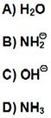
A) A
B) B
C) C
D) D

Answer: B
Difficulty: 2 Medium
Section: 01.14
Topic: Acids and Bases
Bloom's: 2. Understand
Chapter: 01
Subtopic: Predicting acid/base reaction equilibrium

55) Rank the following in order of decreasing acidity. (more acidic > less acidic)
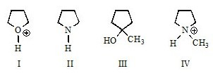
A) I > IV > III > II
B) IV > I > II > III
C) III > II > I > IV
D) I > III > IV > II

Answer: A
Difficulty: 3 Hard
Section: 01.13
Topic: Acids and Bases
Bloom's: 4. Analyze
Chapter: 01
Subtopic: Acid/Base definitions; Factors affecting acid strength

56) Using resonance principles, what atom is acid first protonated in the molecule shown?

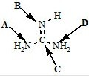
A) A
B) B
C) C
D) D

Answer: B
Difficulty: 3 Hard
Section: 01.13
Topic: Structure and Bonding; Acids and Bases
Bloom's: 4. Analyze
Chapter: 01
Subtopic: Acid/Base definitions; Resonance; Factors affecting acid strength

57) In the equilibrium below, which is the strongest acid?

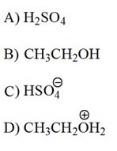
A) A
B) B
C) C
D) D

Answer: A
Difficulty: 2 Medium
Section: 01.14
Topic: Acids and Bases
Bloom's: 2. Understand
Chapter: 01
Subtopic: Predicting acid/base reaction equilibrium; Factors affecting acid strength

58) For which of the following does the equilibrium favor reactants?

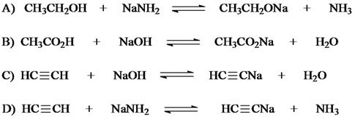
A) A
B) B
C) C
D) D

Answer: C
Difficulty: 3 Hard
Section: 01.14
Topic: Acids and Bases
Bloom's: 4. Analyze
Chapter: 01
Subtopic: Predicting acid/base reaction equilibrium

