Matching Supply with Demand: An Introduction to Operations Management, 4e (Cachon)
Chapter 3 Understanding the Supply Process: Evaluating Process Capacity

1) The Philadelphia Airport has 5 de-icing stations. Each plane uses a single station and each station takes 11.5 minutes to de-ice a plane. How many planes per hour can be de-iced at the Philadelphia Airport? (Round the answer to 2 decimal places.)

Answer: 26.09 planes
Explanation: Each station de-ices 60 min/11.5 min planes per hour. Five stations can de-ice 60/11.5 * 5 = 26.09 planes.
Difficulty: 3 Hard
Topic: Process Utilization and Capacity Utilization
AACSB: Analytical Thinking
Blooms: Apply

2) Consider a process that has 3 stations, ordered in sequence: 1, 2, and 3. At each station, two consecutive tasks are performed one after the other. The time (in seconds per unit) it takes for a single person to perform each task is given in the table below (e.g., task A2 takes 10 seconds per unit):

Station | # of Workers | Task A1 | Task A2 | Task B1 | Task B2 | Task C1 | Task C2
1 | 1 | 20 | 10 | - | - | - | -
2 | 2 | - | - | 40 | 40 | - | -
3 | 1 | - | - | - | - | 1

The table also gives the number of workers at each station. What is the capacity of this process (in units per minute)? (Round the answer to 1 decimal place.)

Answer: 1.5 units/minute
Explanation: The capacity of station 1 is 60/(20 + 10) = 2 units per minute.
Station 2 is 60/(40 + 40) = 0.75 units per worker, or 2 × 0.75 = 1.5 units in total. Station 3 is 60/(15 + 5) = 3 units per minute. The capacity of the process is the capacity of the bottleneck, which is the slowest step. That is station 2, which produces 1.5 units/min.
Difficulty: 3 Hard
Topic: Process Utilization and Capacity Utilization
AACSB: Analytical Thinking
Blooms: Apply
3) Consider the following four step process:

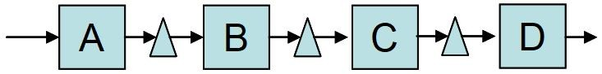

The following data are available for the four steps:

A B C D
Activity time per unit (min) 0.25 0.33 0.2 0.5
Capacity per worker (units/min) 4 3 5 2
Number of workers 2 3 2 4

Suppose the steps in activity D are made easier, so the activity time per unit in step D is reduced by 50% (to 0.25 minutes per unit). If the assignment of workers to steps remains the same, by how much does the capacity of the entire process increase in units per minute?

Answer: 0 units per minute
Explanation: Before the change, the process capacity is min (4 × 2, 3 × 3, 5 × 2, 2 × 4) = 8 units per min. If the activity time is cut in half for stage D, then process capacity for step D is (1/0.25) × 4 = 16 units per min. Step A can only produce 8 units per minute, so the total capacity of the process doesn't increase.
Difficulty: 3 Hard
Topic: How to Draw a Process Flow Diagram; Workload and Implied Utilization
AACSB: Analytical Thinking; Knowledge Application
Blooms: Analyze
4) Panini, a popular sandwich shop, offers 3 types of sandwiches: grilled vegetables, grilled chicken, and pastrami. The table below provides demand data:

 | Grilled Vegetables | Grilled Chicken | Pastrami
Demand per hour | 25 | 15 | 10

There are up to five steps in the process of making sandwiches listed below with activity times. Only 50% of customers want their sandwich toasted, no matter which sandwich is ordered.

Step Grilled Vegetables Grilled Chicken Pastrami
Cut bread .75 minutes .75 minutes .75 minutes
Grill 1.4 minutes 1.4 minutes -
Slice meat - - 3 minutes
Toast 2 minutes 2 minutes 2 minutes
Wrap .5 minutes .5 minutes .5 minutes

Suppose Panini employs 1 worker at each step. What is the highest implied utilization of this process? (Round the answer to 3 decimal places.)

Answer: 0.933
Explanation: Evaluate workload per hour on each step: Cut = 0.75 × 50 = 37.5; Grill = 1.4 × 40 = 56; Slice = 3 × 10 = 30; Toast = 2 × 0.5 × 50 = 50; Wrap = 0.5 × 50 = 25. Implied utilizations are then 37.5/60, 56/60, 30/60, 50/60 and 25/60. The largest one is 56/60. The highest implied utilization = 0.93.
Difficulty: 3 Hard
Topic: Workload and Implied Utilization
AACSB: Analytical Thinking
Blooms: Apply

[The following information applies to questions 5-6.]

Department of Motor Vehicles

The local Department of Motor Vehicles issues new licenses and renews licenses. (See the diagram below.) The office receives 110 customers per hour. All customers see a receptionist first. The receptionist directs them in one of three directions: 75% go directly to issue license (staffed by 9 workers) where a new photo and license are done, 15% are required to take an eye test (staffed by one worker), and 10% must first take a multiple-choice electronic written test (on one of three computers). Only 85% of people pass the eye test and the remaining 15% exit. The customers who pass the eye test proceed to the written test where 10% of the people fail it, while 90% pass the test and proceed to issue license.

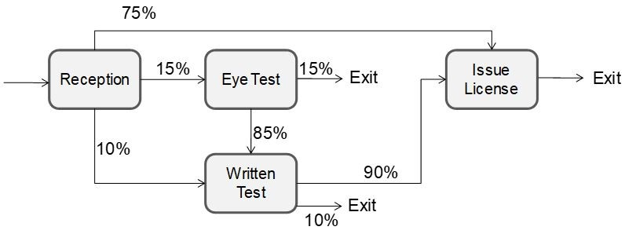

Data on each station are provided in the following table:

Workers Activity time per worker (min)
Reception 1 0.4
Eye Test 1 5
Written Test 3 15
Issue License 9 6

5) What is the implied utilization of the Receptionist? (Round the answer to 2 decimal places.)

Answer: 73.33%.
Explanation:
Processing Capacity per Implied
Workers time (min) Flow rate hour utilization
Reception 1 0.4 110 150 73%
Eye Test 1 5 110 * 0.15 = 16.5 12 138%
Written Test 3 15 110 * 0.1 + 16.5 * 0.85 = 25.025 12 209%
Issue License 9 6 110 * 0.75 + 25.025 * 0.9 = 105.0225 90 117%

Flow rate for receptionist = 110 customers per hour, because all customers first see the receptionist. Hourly Capacity for receptionist = 60 minutes/0.4 minutes per customer = 150 per customer. Implied utilization of the receptionist = 73.33%.
Difficulty: 3 Hard
Topic: How to Draw a Process Flow Diagram; Workload and Implied Utilization
AACSB: Analytical Thinking
Blooms: Apply
6) What is the implied utilization of issue license? (Round the answer to 2 decimal places.)

Answer: 116.69%
Explanation: Implied Utilization = Demand/CapacityFlow rate for issuing a license
75% of the customers go directly to issuing a new license: 0.75 × 110 = 82.5 customers per hour
15% take the eye exam, 0.15 × 110 = 16.5, and 85% of them pass to go to the written test, 0.85 × 16.5 = 14.025 customers
10% go straight to the written test = 0.1 x 110 = 11 customers
90% of the customer pass the written test = 0.9 (11 + 14.025) = 22.5225 customers
The overall flow rate for issuing a license is = 22.5225 + 82.5 = 105.0225 customers per hour. Hourly Capacity for receptionist = 6 minutes/9 workers = 2/3 minutes= 60 minutes / (2/3 minutes) = 90
Implied Utilization of issuing a license = 105.0225/90 = 116.69
The implied utilization of issue license is 116.69%.
Difficulty: 3 Hard
Topic: How to Draw a Process Flow Diagram; Workload and Implied Utilization
AACSB: Analytical Thinking
Blooms: Apply

[The following information applies to questions 7-8.]

Happy Toy Company

The Happy Toy Company's R&D department is always looking for great ideas for new toys. On average, the R&D department generates about 10 new toy ideas a week. To go from idea to approved product, the idea must go through 5 stages:

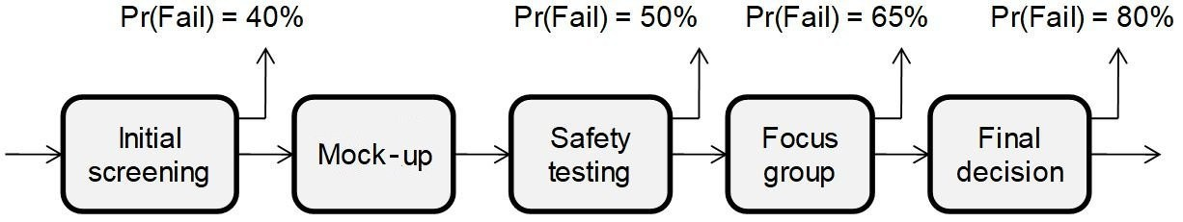

In initial screening, a staff member spends 2 hours considering the idea. In mock-up, the idea is sent to one of many suppliers to produce a physical mock-up of the toy. There is essentially unlimited capacity at this stage, but it takes 4 days to get the mock-up built, even though multiple mock-ups can be built simultaneously. In safety testing, each idea requires 2 days from a staff member to have the idea checked for safety. In focus groups, each idea requires 3 hours from a staff member to have the idea test marketed. Finally, the management team meets for 4 hours per idea to decide if the toy should be added to its line of products sold to customers.

At the end of each stage, successful ideas enter the next stage. All other ideas are dropped. The following table summarizes the process:

Time per idea put
Pr(Success) Pr(Fail) Staffing into this stage
Screening 60% 40% 2 2 hours
Mock-up 4 days
Safety 50% 50% 7 2 days
Focus group 35% 65% 1 3 hours
Final decision 20% 80% 1 4 hours

For example, there are 7 staff members that work in the safety stage. In each stage, each idea is processed by only one staff member. For example, once one of the 7 staff members starts working on an idea in the safety stage, the idea completes that stage in 2 days and either exits or moves to the focus group stage. Everyone works 8 hours per day, 5 days a week.

7) On average, how many ideas are in the mock-up stage? (Round the answer to 1 decimal place.)

Answer: 4.8 ideas
Explanation: Demand for initial screening = 10 ideas per week. Output from initial screening = 10 * 60% = 6 ideas per week. 6 ideas pass the screening stage and then enter the mock-up stage per week. Each idea spends 4 days (5 days per week) or 0.8 weeks in the mock-up stage. Use Little's Law, 6 * 0.8 = 4.8 ideas in the mock-up stage.
Difficulty: 3 Hard
Topic: Process Utilization and Capacity Utilization
AACSB: Analytical Thinking; Knowledge Application
Blooms: Apply

8) Among these stages, what is the highest implied utilization? (Round the answer to 2 decimal places.)

Answer: 34.29%
Explanation: The highest implied utilization is safety, 34.29%.

 | Pr (success) | Pr (Fail) | Staffing | time per idea (hours) | Demand per week | available hours per week | implied utilization
screening | 60% | 40% | 2 | 2 | 10 | 80 | 0.2500
mock-up | 100% | 0 |  | 32 | 6
safety | 50% | 50% | 7 | 16 | 6 | 280 | 0.3429
focus group | 35% | 65% | 1 | 3 | 3 | 40 | 0.2250
final dicision | 20% | 80% | 1 | 4 | 1.05 | 40 | 0.1050

Difficulty: 3 Hard
Topic: Workload and Implied Utilization
AACSB: Analytical Thinking; Knowledge Application
Blooms: Analyze

[The following information applies to questions 9-10.]

Comfy Shoes, Inc. — Implied Utilization
Comfy Shoes, Inc. builds shoes tailored to meet each individual customer's needs. Customers who visit the downtown offices of Comfy Shoes in Philadelphia can choose one or more of the following four custom-tailoring services. Customers receive their shoes in the mail within a week of their initial visit.

Service | Description | Time | Resource used
A. Walking Basics | Take measurements for basic walking shoes. | 12 min. | 1 attendant
B. Walking Plus | Choose a specific design (e.g. material, color selection). | 12 min. | 1 attendant
C. Running Basics | Take measurements for tailor-made running shoes. | 10 min. | 1 attendant
D. Running Adv | Consult physical therapist and obtain precise needs for running shoes and choose a specific design. | 40 min. | 1 attendant

The company offers the following packages to their customers:

Package 1: Includes only Walking Basics (Service A)
Package 2: Includes Walking Basics and Walking Plus (Services A and B)
Package 3: Walking Basics, Walking Plus, and Running Basics (Services A, B, and C)
Package 4: All four services (A, B, C, and D)

Customers of Comfy Shoes visit the store at a constant rate (you can ignore any effects of variability) of 20 customers per day. Of these customers, 45% buy Package 1, 10% buy Package 2, 20% buy Package 3 and 25% buy Package 4. The mix does not change over the course of the day. The store operates 12 hours a day.

9) What is the implied utilization of the attendant in service D?

Answer: Service D has an implied utilization of 28%.
Explanation: The calculations are summarized below:

Package
Time # Avail. 1 2 3 4 Total Utilization
Task (min) workers Cap. 0.45 0.10 0.20 0.25
A. Walking Basics 12 1 60 9 2 4 5 20 0.33
B. Walking Plus 12 1 60 2 4 5 11 0.183
C. Running Basics 10 1 60 3.33 4.166 7.5 0.125
D. Running Adv 40 1 60 16.66 16.66 0.278
Difficulty: 3 Hard
Topic: Workload and Implied Utilization
AACSB: Analytical Thinking
Blooms: Analyze
10) Which resource has the highest implied utilization?
A) Service A (Walking Basics)
B) Service B (Walking Plus)
C) Service C (Running Basics)
D) Service D (Running Adv)

Answer: A
Explanation: Service A (Walking Basics) has the highest implied utilization.
Difficulty: 3 Hard
Topic: Workload and Implied Utilization
AACSB: Analytical Thinking
Blooms: Analyze

[The following information applies to questions 11-12.]

Comfy Shoes, Inc. — Bottleneck

At the end of the spring season, Comfy Shoes anticipates an increase in the demand to 50 customers per day. A change in the mix of packages demanded is also expected: 30% of the customers ask for Package 1, 10% for Package 2, 10% for Package 3 and 50% for Package 4. The company will hire an additional attendant to help with Service A (Walking Basics).

11) What will be the bottleneck in the process given this new demand pattern?
A) Service A (Walking Basics)
B) Service B (Walking Plus)
C) Service C (Running Basics)
D) Service D (Running Adv)

Answer: D
Explanation: Calculations are as follows:

Package
Time # Avail. 1 2 3 4 Total Utilization
Task (min) workers Cap. 0.3 0.10 0.10 0.5
A. Walking Basics 12 2 120 15 5 5 25 50 0.417
B. Walking Plus 12 1 60 5 5 25 35 0.58
C. Running Basics 10 1 60 4.166 20.83 25 0.4166
D. Running Adv 40 1 60 83.33 83.33 1.388

Difficulty: 3 Hard
Topic: Bottleneck, Process Capacity, and Flow Rate (Throughput)
AACSB: Analytical Thinking
Blooms: Analyze
12) How many customers a day will not be served?

Answer: 7 customers
Explanation: Service D receives 0.5*(50/12)*40=83.33 minutes of work every hour. Only 60 minutes of work can be served. Thus, every hour, 23.33 minutes of work, or 23.33/40th of a customer is not served. Customers not served in a day = [(83.333 – 60)/40]*12=7 customers a day will not be served. Put another way, the worker has 60x12=720 minutes available each day. 40 min per customer means that 720/40=18 customers can be served. 50% of 50 = 25 customers arrive each day, so 25–18=7 cannot be served.
Difficulty: 3 Hard
Topic: Bottleneck, Process Capacity, and Flow Rate (Throughput)
AACSB: Analytical Thinking; Knowledge Application
Blooms: Analyze

[The following information applies to questions 13-15.]

Old City Photographics

Located alongside a cobblestoned street in Old City, Old City Photographics (OCP) specializes in the processing of the traditional 35mm negative film, a once dominant photographic medium now in decline due to the popularity of digital photography. OCP offers three packages to their customers. With the standard package, the customer gets a set of 6"×4" prints for $19.99. The deluxe package adds to the standard package a CD-ROM of high-resolution scans of the pictures for $29.99. Finally, the $39.99 pro package is similar to the deluxe package in that it comes with a CD-ROM, although the customer gets a contact print rather than a set of prints. (A contact print is an 8"×10" sheet of photographic paper that has all pictures on the roll of film printed next to each other at reduced dimensions and is used as an index.) The workflow for OCP is shown below (s = standard, d = deluxe, p = pro):

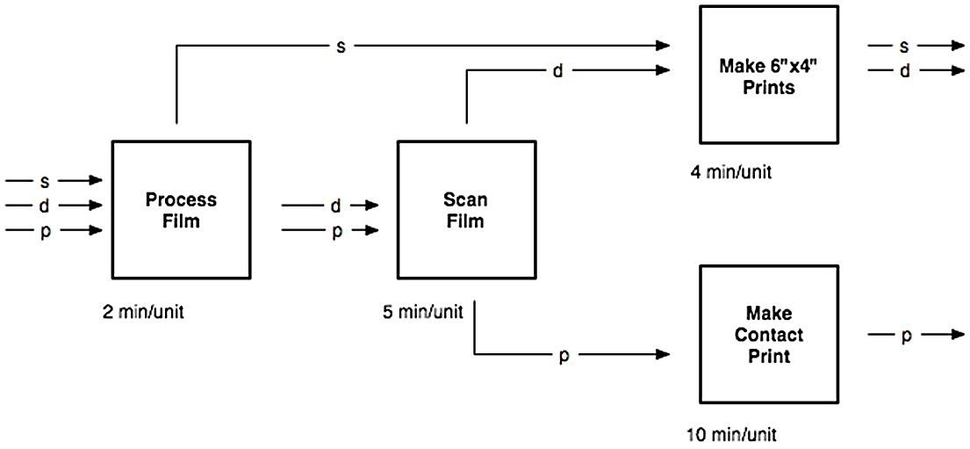

OCP is operated by one person at every station.

13) On average, OCP receives 13 jobs per hour which consist of 44% standard, 37% deluxe and 19% pro. Which of the following statement best describes OCP's process?
A) The process is demand-constrained.
B) The process is capacity-constrained and "process film" is the bottleneck
C) The process is capacity-constrained and "scan film" is the bottleneck.
D) The process is capacity-constrained and "make 6"×4" prints" is the bottleneck.
E) The process is capacity-constrained and "make contact print" is the bottleneck.

Answer: A
Explanation: Implied utilization is:
(100% * 13 jobs/hr * 2min/job ) / (60 min/hr) = 0.43 at "process film"
((37% + 19%) * 13 jobs/hr * 5 min/job ) / (60 min/hr) = 0.61 at "scan film"
((44% + 37%) * 13 jobs/hr * 4 min/job) / (60 min/hr) = 0.70 at "make 6"×4" prints"
(19% * 13 jobs/hr * 10 min/job) / (60 min/hr) = 0.41 at "make contact print"
As implied utilization is less than 1.0 at all steps, the process is demand-constrained.
Difficulty: 3 Hard
Topic: Bottleneck, Process Capacity, and Flow Rate (Throughput)
AACSB: Analytical Thinking; Knowledge Application
Blooms: Analyze

14) What is the implied utilization (ratio of workload relative to capacity) at "Scan Film"?
A) less than 50%
B) 50% to 60%
C) 60% to 70%
D) 80% to 90%
E) 90% to 100%
F) more than 100%

Answer: C
Explanation: ((37% + 19%) * 13 jobs/hr * 5 min/job ) / (60 min/hr) = 0.61
Difficulty: 3 Hard
Topic: Workload and Implied Utilization
AACSB: Analytical Thinking
Blooms: Apply
15) Fixing the relative proportions of job types, what is the largest number of jobs per hour that OCP can handle? Choose the answer from the list below that is closest to the correct answer.
A) 10
B) 11
C) 12
D) 13
E) 14
F) 15
G) 16
H) 17
J) 18

Answer: J
Explanation: From the calculations for OCP1, we know that "make 6"×4" prints" will become the bottleneck once the process is capacity-constrained (if the mix of jobs does not change). The answer to our present question is given by the solution X to the equation ((44% + 37%) * X jobs/hr * 4 min/job) / (60 min/hr) = 1.00.

Re-arranging the equation yields X = (60 min/hr) / (81% * 4 min/job) = 18.5 jobs/hr.
Difficulty: 3 Hard
Topic: Multiple Types of Flow Units
AACSB: Analytical Thinking; Knowledge Application
Blooms: Analyze

