Chapter One Study Questions
- According to Thorstein Veblen, who primarily played sports in the latter 19th century?
Solution: The wealthy or the leisure class primarily played sports in the latter 19th century.

- How many boys and girls play high school sports today?
Solution: More than 4 million boys and more than 3 million girls play high school sports today.

- How does viewership of the Super Bowl (the biggest game in American football) compare to viewership of a regular-season soccer match (international football) in Spain?
Solution: Viewership for the Super Bowl is 160 million, while viewership for a regular-season soccer match in Spain is 400 million.

- What percentage of sports fans are women? What percentage of the sports media are women?
Solution: Thirty to 45% of sports fans are women; 10% of the sports media are women.

- According to former President Barack Obama (and he was far from alone in making this argument), what is the relationship between player salaries and ticket prices?
Solution: Higher player salaries cause higher ticket prices.

- According to Humphreys and Ruseski (2009), what is the size of the U.S. sports market?
Solution: The size of the U.S. sports market is $44 to $60 billion.

- According to John Maynard Keynes, what is the purpose of economic analysis (according to Alfred Marshall)? What does an economist need to engage in such an analysis? If we apply this perspective to the study of sports economics, what does an economist need to study sports?
Solution: According to Keynes, Marshall says that the purpose of economic analysis is to apply the theory to “current economic life.” To do this, one must know the facts of the industry. So to study sports, an economist needs to know sports in addition to economics.

- What are the tongue-in-cheek steps to the Marshallian method? How can they be applied to the question that was the starting point for this chapter?
Solution: Use mathematics as a shorthand language rather than as an engine of inquiry, and keep at it until you are done. Translate into English and illustrate by examples that are important in real life. The question at the beginning of the chapter is, What determines ticket prices in professional sports? The Marshallian method was applied throughout the chapter, first formulating a demand curve, then stating it in English, and then examining real-world data to see how this works.

- What are the key words in the definition of supply and demand?
Solution: You must be “willing and able.” To be in supply or demand of a good, you have to be able and willing to participate in the market.

- With respect to the demand for baseball tickets, what are factors that:
  - cause movement along the demand curve?
Solution: A change in the price of the good causes movement along the demand curve.
  - cause the demand curve to shift?
Solution: A change in any demand factor besides the price of the good will cause the demand curve to shift. This includes personal income, market size, changes in quality of the good, and so on.

- What part of the demand curve changes when the curve is shifted? What part of the demand curve should not change?
Solution: The y-intercept changes when the curve shifts. The slope does not change.

- What has determined the price of Honus Wagner’s baseball card over time? Be able to illustrate this story (i.e., draw a supply and demand graph).
Solution: As incomes have increased among baseball fans, demand for the card has increased. But since only a certain number of cards were printed, supply has remained fixed. With a fixed supply, demand solely determines the price, so the price of the cards has increased significantly. At a 2013 auction, one of Wagner’s cards sold for $2.1 million.
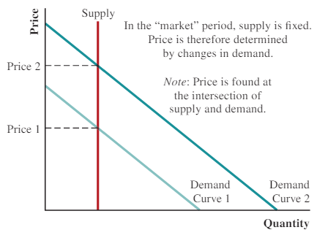
- How is the market period different from the normal period in Marshall’s analysis of prices?
Solution: Market period is when supplied is fixed, so prices are determined entirely by changes in demand. Normal period has an upward-sloping supply curve.

- Why did Nike take Reebok to court over the production of Tim Tebow jerseys in the Spring of 2012? Be able to illustrate this story.
Solution: Nike had the right to make and sell the jersey. If Reebok also made the jersey, supply would increase and the price of the jersey would decline.
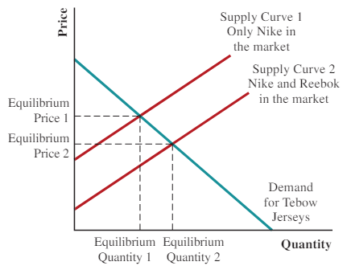

- According to Marshall’s supply and demand model, what determines the price of tickets in the NBA? Be able to illustrate this story.
Solution: Price of tickets is determined by demand.
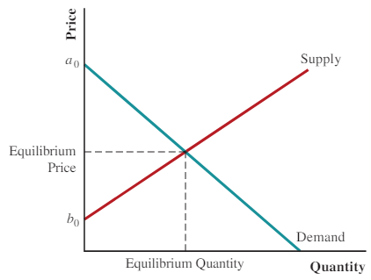
- How does the NBA’s salary cap impact quantity demand and quantity supplied of labor in the NBA’s player market? What is the intent of this cap? According to the text, what is the actual impact of this cap?
Solution: The NBA’s salary cap is a price ceiling set below the equilibrium wage for the NBA player’s market. With this price ceiling in place, no team can offer more money than the NBA maximum even though it might be willing to pay this maximum. This cap was intended to prevent the richest NBA teams from assembling a team that would dominate the league. By forcing the price of stars below the equilibrium wage, all teams should be able to acquire top talent. But in reality, star players consider factors besides the wage in determining where they will play, such as their chances of winning a title. So the policy falls short of preventing a team that dominates the league.

- Is there a “right” price for labor? Utilize the perspective of John Stuart Mill in answering this question.
Solution: There is no “right” price for labor. What labor is paid depends on the laws of society.

- What is the difference between positive and normative economics (according to John Neville Keynes)? How are “morality” and “economics” summarized by Steven Levitt and Stephen Dubner?
Solution: Positive economics is the study of “what is,” and normative economics is the study of “what ought to be.” Morality, it could be argued, represents the way that people would like the world to work—whereas economics represents how it actually does work.

- What is deductive reasoning? What is inductive reasoning?
Solution: Deductive reasoning is moving from the general to the specific. With deductive reasoning one begins with basic principles and then logically derives a model of how the world works. Inductive reasons begins with data and then derives a theory.

- According to Marshall, what is the basic approach to economics?
Solution: Economics is not dogma, and it is not a collection of universal truths. The tools of economics, including both deductive and inductive reasoning, simply provide us with the means to uncover how the world appears to work.

Thought Questions
- Tim Tebow’s NFL career ended with the New York Jets in 2012. How would his lack of success with the Jets impact the price of his Jets jersey? Now imagine Tebow becomes a media celebrity in New York when his athletic career finally ends (currently he is a minor league baseball player). How might that impact the price of this jersey? If Tebow becomes a media celebrity in New York, could we deduce the price of his Jets jersey in the future (i.e., ascertain its value without analyzing data)?
Solution: His lack of success in football lowers demand for the jersey and therefore lowers the price. But media success might cause demand to increase. If both events happened, the price of Tebow’s jersey could not be simply deduced.

- At the conclusion of the 2016 college football season, the University of Alabama’s football team had existed for 113 years, appeared in 66 bowl games, and won 26 conference titles. Utilize what you know about the NCAA’s limit on compensation of college athletes to explain the dominance of this football team.
Solution: Because all NCAA schools essentially pay the same wage, athletes use a different criteria to select their school. The most obvious criteria is the likelihood that the team will win. That means the top athletes, who have the most choices, tend to choose the same schools with a history of winning. And that means schools like Alabama will persistently win.

Math Questions
- Define the elements of the following equation: P = a₀ – a₁ × Q_{d}.
Solution:
P = dependent variable
Q_{d} = independent variable
a₀ = y-intercept
a₁ = slope coefficient

- Given P = $150 – 0.005 × Q_{d} as the demand for a professional sports team:
- If P = $60, what is Q_{d}?
Solution: 18,000
- If P = $40, what is Q_{d}?
Solution: 22,000
- Imagine these two possible changes from the demand curve listed in Question 2:
  - P = $175 – 0.005 × Q_{d}
  - P = $125 – 0.005 × Q_{d}
For each, identify whether Question 3(a) or 3(b) would be consistent with the following stated changes:
    - increase in the size of the market where the team plays
Solution: a
    - decrease in the per-capita income in the market where the team plays
Solution: b
    - move to a newer stadium
Solution: a
    - decline in the quality of players employed by the team
Solution: b
- Define the elements of the following equation: P = b₀ + b₁ × Q_{S}.
Solution:
P = price of a good
Q_{S} = quantity supplied of a good
b₀ = y-intercept
b₁ = slope coefficient

