Chapter 1

Answers to Exercises 1
Answers will vary.

Chapter 2

Answers to Exercises 2
The answers are the maps and the legends. Students should be given feedback on choice of colors and symbols, use of informative legend text, use of appropriate formatting for legend values, and choice of classification methods and normalization, etc.
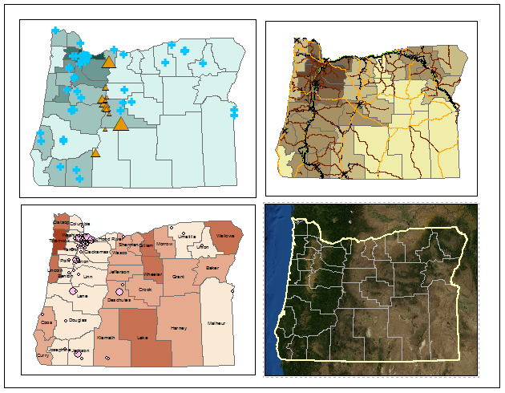
Source: Esri

Chapter 1

Answers to Review Questions 1
- Discrete data are objects that exist in one place and not another, such as rivers, states, or wells. Continuous data store a value that could be measured anywhere, such as rainfall, temperature, or slope.
- The length of the pool in the map is 2 cm = 0.02 meters. Set up the ratio 0.02 m/50 m = 1/x and solve for x, obtaining x = 2500. The scale is thus 1:2,500.
- A map scale is established by drawing a map on paper or a screen. GIS data can be viewed at many different scales by zooming in/out, so it has no map scale, only locations. However, a data set inherits a source scale from the original paper map on which it is based.
- Originally, GIS data were primarily stored on a local or network hard drive, used in a GIS program, and obtained by downloads or CD/DVD media. Now, live Internet sources are increasingly used and can be consumed by a wider variety of devices.
- The uncertainty of 25-50 meters in location, at the typical scale needed to navigate a hiking train, would not be considered precise in this example, nor would his map be highly accurate.
- Smartphones can be variable in accuracy depending on location and service. Plus, the location of the bird-watcher will often not be the exact location of the bird, so the positional accuracy of this data set is likely 10-50 meters overall. The attribute accuracy will be affected by each contributor’s expertise in recognizing species and how well the bird is seen or heard. The resolution will be variable; she may get more sightings on weekends or during pleasant weather. Some areas will be visited frequently by many bird-watchers and other areas may have no data at all, and the availability of roads and trails will also affect where data are collected. The temporal resolution is coarse, as she will be collecting data over many days and possibly seasons that may affect which birds are present.
- Mastering ArcGIS Pro Tutorial Data, 1st edition (2018) [download]. McGraw-Hill Higher Ed: Dubuque, Iowa.
- Windows are work areas that may hold either views or panes. A view is an object that the user is working with, like a map or a table. A pane contains commands or settings that affect the current view object.
- Tools are small programs that perform a specific task. Parameters are settings that affect how the tool executes.
- Core ribbons are always shown in the ribbon interface, but contextual ribbons only appear when the corresponding object is selected or being used.

Answers to Tutorial Questions 1
- The lake area is 5,412 hectares.
- Vents contains point data, faults and bathymetry contain line data, and the polygon data sets include floorgeology, geologyunits, lake, ParkBoundary, and topocliparea. The rasters are dem30m and hillshade10m.
- No, the name did not update in the 3D scene.
- USA Mean Temperature (2016) [imagery layer]. US Geological Survey on ArcGIS Online. URL: https://landscape3.arcgis.com/arcgis/rest/services/USA_Mean_Temperature /ImageServer [August, 2017].
- There are 36 counties, with an average population of 108,964.
- Wheeler has 1460 and Multnomah has 759,000.

Answers to Exercises 1
Answers will vary.

