Chapter 1  
Introduction  
Solution to Solved Problems

# 1.S1 Make or Buy

Power Notebooks, Inc. plans to manufacture a new line of notebook computers. Management is trying to decide whether to purchase the LCD screens for the computers from an outside supplier or to manufacture the screens in-house. The screens cost $100 each from the outside supplier. To set up the assembly process required to produce the screens in-house would cost $100,000. The company could then produce each screen for $75. The number of notebooks that eventually will be produced (Q) is unknown at this point.

a. Set up a spreadsheet that will display the total cost of both options for any value of Q. Use trial-and-error with the spreadsheet to determine the range of production volumes for which each alternative is best.

If Power Notebooks purchases the screens, the fixed cost is $0 and the unit cost is $100. These data are entered into B2:B3.  
  
If Power Notebooks manufactures the screens, the fixed cost is $100,000 and the unit cost is $75. These data are entered into D2:D3.  
  
The number of LCD screens needed (*Q*) is unknown. Cell C6 will be used for this quantity.  
  
In general, *Total Cost* = *Fixed Cost* + (*Unit Cost*)(*LCD Screens Needed*). This formula is entered into B4 and D4.  
  
Trial and error with the spreadsheet shows that purchasing is cheaper if *Q* < 4000, manufacturing is cheaper if *Q* > 4000, and the costs are identical when *Q* = 4000.  
  
The spreadsheet is shown below.

   
  


b. Use a graphical procedure to determine the break-even point for Q (i.e., the quantity at which both options yield the same cost).

To determine the ranges of *Q* for which each source is cheapest, graph the total cost versus *Q*, as shown below. The total cost lines cross at *Q* = 4,000. This is the break-even point for *Q*.  
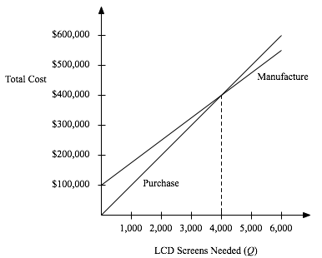

c. Use an algebraic procedure to determine the break-even point for Q.

The total cost if Power Notebooks purchases the LCD screens is *TC*purchase = ($100)*Q*.  
The total cost if Power Notebooks manufactures the LCD screens is *TC*manufacture = $100,000 + ($75)*Q*.  
The break-even point for *Q* occurs when *TC*purchase = *TC*manufacture.  
($100)*Q* = $100,000 + ($75)*Q* when ($25)*Q* = $100,000, or *Q* = 4,000.

