Solutions to Chapter 1 Exercises

Describe the three phases of the evolution of forecasting/prediction.

The earliest phase in the evolution of forecasting was when all forecasts were purely judgmental. Forecasts were based solely on the intuition of managers who had to predict how much would be sold, or how much inventory to order, or how many people to hire (or all of these). Later quantitative methods and forms of numerical analyses started to be used to make predictions. Methods such as moving averages and simple exponential smoothing were followed by more sophisticated time series methods such as Holt’s and Winters’ exponential smoothing. Linear time trends came into use, at first by an analysts drawing freehand lines through the data that they “believed” best represented the trend in the data. Later basic regression tools were used for such simple time trends. As quantitative methods became more sophisticated, and as computer power enabled their use, quantitative forecasting became dominant and has been shown to outperform qualitative methods most of the time. We are now into the “big data” phase in which we have not only the ability to use numeric data but have immense amounts of non-numeric data that can contribute to the accuracy of predictions.
- How does the organization of the material in this book relate to the stages of the evolution of prediction?
The text is organized around three major themes: 1) Time Series Models; 2) Demand Planning Models; and 3) Analytics. The text has an overview of some qualitative methods but the real powerful forecasting methods begin in Chapters 3 and 4 that focus on various time series methods. Chapter 5 delves heavily into causal models using multiple regression that can include variables over which the organization has partial or total control. Chapters 6 and 7 continue the demand planning section. Then in Chapter 8 predictive analytics take center stage. This is the new frontier of prediction and forecasting.
- Write a paragraph in which you compare what you think are the advantages and disadvantages of subjective forecasting methods. How do you think the use of quantitative methods relates to these advantages and disadvantages?
One advantage of subjective forecasting is that this class of methods does not require quantitative skill on the part of the forecaster or the user. Historically, a related advantage was that sophisticated computer software is not needed for subjective forecasting. In addition, the results of subjective forecasts were widely accepted by management. This acceptance may have been due to the ability of successful forecasters to sense changes based on a subjective understanding of the business/economic environment. Unfortunately it takes years for a forecaster to learn to translate intuition into a reliable forecast. The ability to make subjective forecasts is very difficult to transfer to other individuals which means that when that forecaster retires or moves to another position forecast accuracy typically suffers. Thus, over time consistency in forecast accuracy is difficult to maintain. Perhaps the biggest disadvantage of subjective forecasts is that they almost always are biased.
- Explain how forecasting relates to having an efficient supply chain.
For a supply chain to function efficiently all the participants along the chain must have accurate forecasts in order to plan production and distribution. Consider a firm that makes seats for a major auto manufacturer. This firm needs a reliable forecast of the production of vehicles so that they can plan their raw material and human resource requirements.
- The process of forecasting new products is difficult. Why? How can new products be forecast?
The biggest hurtle to overcome in new product forecasting is the lack of historical data. In the most extreme case of a totally new product there is no historical data that can be used to help develop a forecast. Often a new product is not completely new to the market. There may be similar products on the market for which there is a body of data that might be useful. Consider the newest iPhone. Apple has historical data on previous versions of the iPhone that can be a guide to expected sales of the newest model. When a product is totally new a firm can rely on marketing research in the form of test markets and product clinics to develop estimates of future sales. Once the product is introduced and a few data points have been observed the Bass model may be useful. Products typically follow a product life cycle which provides a framework for developing sales estimates.
- In this chapter, you saw an example of a naive forecast. Why do you think it is given that name? Describe how the naive forecast is developed.
Naïve forecasts are given that name because they simply assume that the next period will be the same as the current period. This is truly a naïve assumption. Most people use a naïve forecast in their daily lives. In the absence of a weather forecast, it is not uncommon to think that the weather tomorrow will be the same as it is today. Most of the time this works well enough in the very short term but such a forecast becomes absurd in a longer term. It is likely that the weather on January 15 will be similar to the weather January 14th. But extending that reasoning six months ahead the June 15 would be unreasonable. In the simplest form a naïve forecast takes today’s sales as the forecast for tomorrow’s sales. That is the forecast for time period t+1 is the actual value at time period t.
- In the chapter, you learned about many metrics that can be used to evaluate forecast accuracy. The MAPE was one of those that may be the most common in use. Explain what the MAPE tells a forecaster.
MAPE stands for “Mean Absolute Percentage Error.” The MAPE is one form of an average error in a forecast over a specific period of time. Because the absolute value of the errors are used in the calculation it is not possible for positive errors to offset negative errors. Suppose you have a forecast for four quarters with errors of 100. 50, -225, and 175. Calculating a simple average would tell you that on average there was zero error. In fact this is quite obviously not true. For simplicity assume that actual sales for the four periods were as shown in the table below. The MAPE would be calculated as shown below:
Actual | Forecast | Error | Absolute Error | Absolute % Error
400 | 300 | 100 | 100 | 25.00
200 | 150 | 50 | 50 | 25.00
500 | 725 | -225 | 225 | 45.00
400 | 225 | 175 | 175 | 43.75
 |  |  | MAPE = | 34.69
The MAPE for the same four periods would be 34.69 which would be a better indication of the true errors in the forecast and would not mislead a manager into thinking the forecasts had all been perfect. MAPE is also unit free since it is calculated as a percent. Thus, the MAPE can be compared across different forecast items.
- Suppose that you work for a U.S. senator who is contemplating writing a bill that would put a national sales tax in place. Because the tax would be levied on the sales revenue of retail stores, the senator has asked you to prepare a forecast of retail store sales for year 8, based on data from year 1 through year 7. The data are:

(c1p8) | Year | Retail Store Sales
 | 1 | $ 1,225
 | 2 | 1,285
 | 3 | 1,359
 | 4 | 1,392
 | 5 | 1,443
 | 6 | 1,474
 | 7 | 1,467
- Use the naive forecasting model presented in this chapter to prepare a forecast of retail store sales for each year from 2 through 8.
Year | Retail Store Sales | Naïve Forecast
1 | 1,225
2 | 1,285 | 1,225
3 | 1,359 | 1,285
4 | 1,392 | 1,359
5 | 1,443 | 1,392
6 | 1,474 | 1,443
7 | 1,467 | 1,474
8 |  | 1,467

- Prepare a time-series graph of the actual and forecast values of retail store sales for the entire period. (You will not have a forecast for year 1 or an actual value for year 8.)
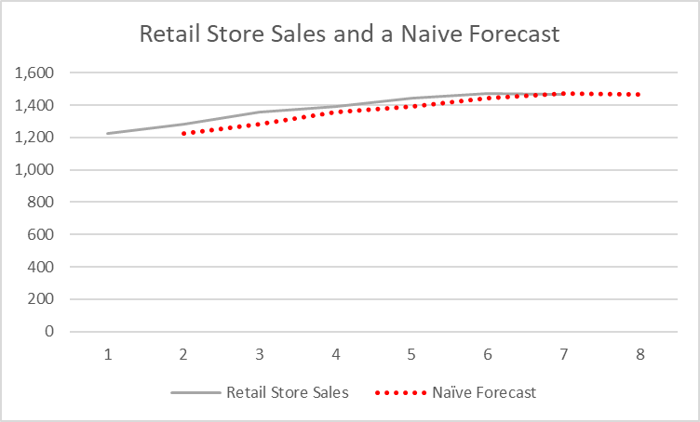
- Calculate the MAPE for your forecast series using the values for year 2 through year 7.
Year | Retail Store Sales | Naïve Forecast | Error | Absolute Error | Absolute % Error
1 | 1225
2 | 1285 | 1225 | 60 | 60 | 4.67
3 | 1359 | 1285 | 74 | 74 | 5.45
4 | 1392 | 1359 | 33 | 33 | 2.37
5 | 1443 | 1392 | 51 | 51 | 3.53
6 | 1474 | 1443 | 31 | 31 | 2.10
7 | 1467 | 1474 | -7 | 7 | 0.48
8 |  | 1467
 |  |  |  | MAPE = | 3.10

- Suppose that you work for a major U.S. retail department store that has outlets nationwide. The store offers credit to customers in various forms, including store credit cards, and over the years has seen a substantial increase in credit purchases. The manager of credit sales is concerned about the degree to which consumers are using credit and has started to track the ratio of consumer installment credit to personal income. She calls this ratio the credit percent, or CP, and has asked that you forecast that series for year 8. The available data are:
(c1p9) | Year | CP
 | 1 | 12.96
 | 2 | 14.31
 | 3 | 15.34
 | 4 | 15.49
 | 5 | 15.70
 | 6 | 16.00
 | 7 | 15.62
- Use the first naive model presented in this chapter to prepare forecasts of CP for years 2 through 8.
Year | CP | Naïve Forecast
1 | 13
2 | 14 | 13
3 | 15 | 14
4 | 15 | 15
5 | 16 | 15
6 | 16 | 16
7 | 16 | 16
8 |  | 16

- Plot the actual and forecast values of the series for the years 1 through 8. (You will not have an actual value for year 8 or a forecast value for year 1.)
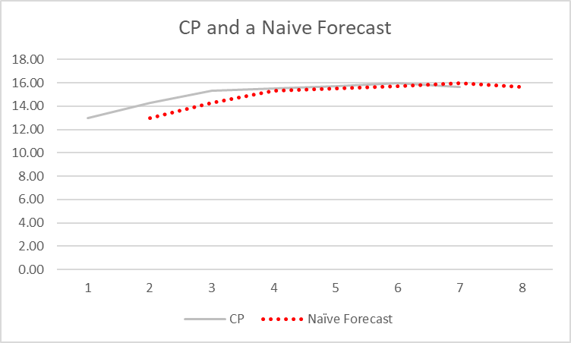
- Calculate the MAPE for your forecasts for years 2 through 7.
Year | CP | Naïve Forecast | Error | Absolute Error | Absolute % Error
1 | 12.96
2 | 14.31 | 12.96 | 1.35 | 1.35 | 9.43
3 | 15.34 | 14.31 | 1.03 | 1.03 | 6.71
4 | 15.49 | 15.34 | 0.15 | 0.15 | 0.97
5 | 15.7 | 15.49 | 0.21 | 0.21 | 1.34
6 | 16 | 15.7 | 0.3 | 0.3 | 1.88
7 | 15.62 | 16 | -0.38 | 0.38 | 2.43
8 |  | 15.62
 |  |  |  | MAPE = | 3.79

- Go to the library and look up annual data for population in the United States from 2000 through the most recent year available. This series is available at a number of Internet sites, including http://www.economagic.com. Plot the actual data along with the forecast you would get by using the basic naive model discussed in this chapter.
Year | U.S. Population
2,000 | 282,162,411
2,001 | 284,968,955
2,002 | 287,625,193
2,003 | 290,107,933
2,004 | 292,805,298
2,005 | 295,516,599
2,006 | 298,379,912
2,007 | 301,231,207
2,008 | 304,093,966
2,009 | 306,771,529
2,010 | 309,346,863
2,011 | 311,718,857
2,012 | 314,102,623
2,013 | 316,427,395
2,014 | 318,907,401
2,015 | 321,418,820
2,016
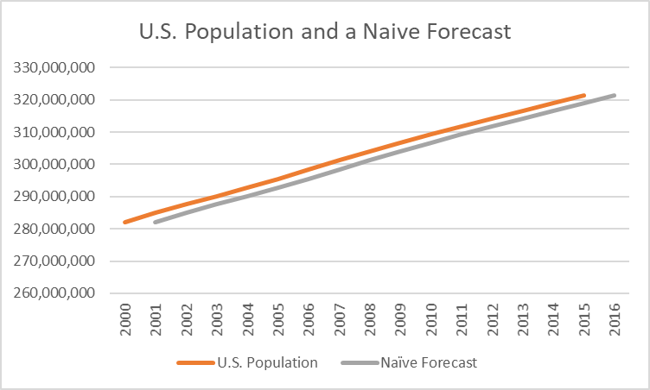

- CoastCo Insurance, Inc., is interested in developing a forecast of larceny thefts in the United States. It has found the following data:

(c1p11) | Year | Larceny Thefts* | Year | Larceny Thefts*
 | 1 | 4,151 | 10 | 7,194
 | 2 | 4,348 | 11 | 7,143
 | 3 | 5,263 | 12 | 6,713
 | 4 | 5,978 | 13 | 6,592
 | 5 | 6,271 | 14 | 6,926
 | 6 | 5,906 | 15 | 7,257
 | 7 | 5,983 | 16 | 7,500
 | 8 | 6,578 | 17 | 7,706
 | 9 | 7,137 | 18 | 7,872
Plot this series in a time-series plot and make a naive forecast for years 2 through 19.
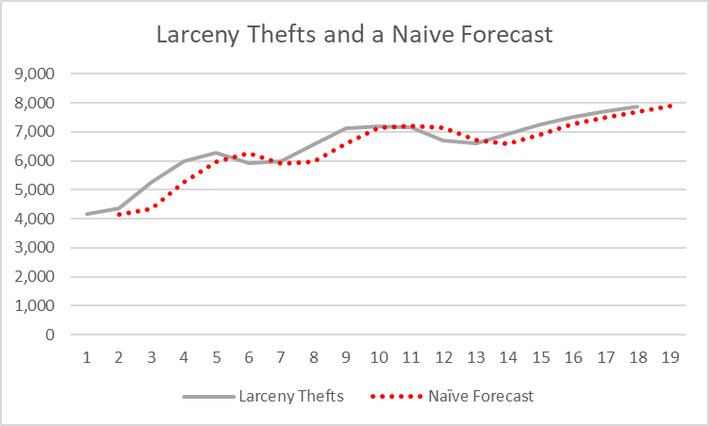
Calculate the MAPE for years 2 through 18.
Year | Larceny Thefts | Naïve Forecast | Error | Absolute Error | Absolute % Error
1 | 4,151
2 | 4,348 | 4,151 | 197 | 197 | 4.53
3 | 5,263 | 4,348 | 915 | 915 | 17.39
4 | 5,978 | 5,263 | 715 | 715 | 11.96
5 | 6,271 | 5,978 | 293 | 293 | 4.67
6 | 5,906 | 6,271 | -365 | 365 | 6.18
7 | 5,983 | 5,906 | 77 | 77 | 1.29
8 | 6,578 | 5,983 | 595 | 595 | 9.05
9 | 7,137 | 6,578 | 559 | 559 | 7.83
10 | 7,194 | 7,137 | 57 | 57 | 0.79
11 | 7,143 | 7,194 | -51 | 51 | 0.71
12 | 6,713 | 7,143 | -430 | 430 | 6.41
13 | 6,592 | 6,713 | -121 | 121 | 1.84
14 | 6,926 | 6,592 | 334 | 334 | 4.82
15 | 7,257 | 6,926 | 331 | 331 | 4.56
16 | 7,500 | 7,257 | 243 | 243 | 3.24
17 | 7,706 | 7,500 | 206 | 206 | 2.67
18 | 7,872 | 7,706 | 166 | 166 | 2.11
19 |  | 7,872
 |  |  |  | MAPE = | 5.30

On the basis of these measures and what you see in the plot, what do you think of your forecast? Explain.
The plot shows that the naïve forecast always takes the actual value as the forecast for the next period which is clear in both the table and the graph. When the actual is going up the forecast is consistently low and when the actual is going down the forecast is high.
- As the world’s economy becomes increasingly interdependent, various exchange rates between currencies have become important in making business decisions. For many U.S. businesses, the Japanese exchange rate (in yen per U.S. dollar) is an important decision variable. This exchange rate (EXRJ) is shown in the following table by month for a two-year period: (c1p12)
Period | EXRJ
1 | 127.36
2 | 127.74
3 | 130.55
4 | 132.04
5 | 137.86
6 | 143.98
7 | 140.42
8 | 141.49
9 | 145.07
10 | 142.21
11 | 143.53
12 | 143.69
13 | 144.98
14 | 145.69
15 | 153.31
16 | 158.46
17 | 154.04
18 | 153.7
19 | 149.04
20 | 147.46
21 | 138.44
22 | 129.59
23 | 129.22
24 | 133.89

Prepare a time-series plot of this series, and use the naive forecasting model to forecast EXRJ for each month from year 1 M2 (February) through year 3 M1 (January).
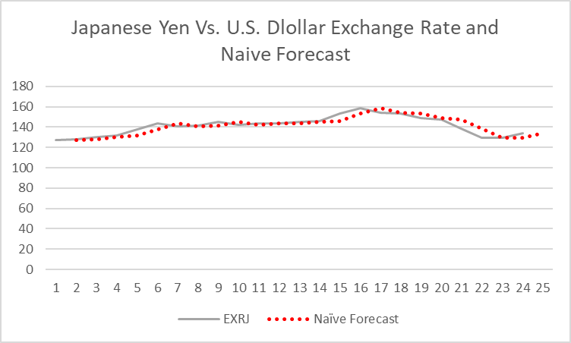
Period | EXRJ | Naïve Forecast
1 | 127.36
2 | 127.74 | 127.36
3 | 130.55 | 127.74
4 | 132.04 | 130.55
5 | 137.86 | 132.04
6 | 143.98 | 137.86
7 | 140.42 | 143.98
8 | 141.49 | 140.42
9 | 145.07 | 141.49
10 | 142.21 | 145.07
11 | 143.53 | 142.21
12 | 143.69 | 143.53
13 | 144.98 | 143.69
14 | 145.69 | 144.98
15 | 153.31 | 145.69
16 | 158.46 | 153.31
17 | 154.04 | 158.46
18 | 153.7 | 154.04
19 | 149.04 | 153.7
20 | 147.46 | 149.04
21 | 138.44 | 147.46
22 | 129.59 | 138.44
23 | 129.22 | 129.59
24 | 133.89 | 129.22
25 |  | 133.89
Calculate the MAPE for the period from year 1 M2 through year 2 M12.
Period | EXRJ | Naïve Forecast | Error | Absolute Error | Absolute % Error
1 | 127.36
2 | 127.74 | 127.36 | 0.38 | 0.38 | 0.30
3 | 130.55 | 127.74 | 2.81 | 2.81 | 2.15
4 | 132.04 | 130.55 | 1.49 | 1.49 | 1.13
5 | 137.86 | 132.04 | 5.82 | 5.82 | 4.22
6 | 143.98 | 137.86 | 6.12 | 6.12 | 4.25
7 | 140.42 | 143.98 | -3.56 | 3.56 | 2.54
8 | 141.49 | 140.42 | 1.07 | 1.07 | 0.76
9 | 145.07 | 141.49 | 3.58 | 3.58 | 2.47
10 | 142.21 | 145.07 | -2.86 | 2.86 | 2.01
11 | 143.53 | 142.21 | 1.32 | 1.32 | 0.92
12 | 143.69 | 143.53 | 0.16 | 0.16 | 0.11
13 | 144.98 | 143.69 | 1.29 | 1.29 | 0.89
14 | 145.69 | 144.98 | 0.71 | 0.71 | 0.49
15 | 153.31 | 145.69 | 7.62 | 7.62 | 4.97
16 | 158.46 | 153.31 | 5.15 | 5.15 | 3.25
17 | 154.04 | 158.46 | -4.42 | 4.42 | 2.87
18 | 153.7 | 154.04 | -0.34 | 0.34 | 0.22
19 | 149.04 | 153.7 | -4.66 | 4.66 | 3.13
20 | 147.46 | 149.04 | -1.58 | 1.58 | 1.07
21 | 138.44 | 147.46 | -9.02 | 9.02 | 6.52
22 | 129.59 | 138.44 | -8.85 | 8.85 | 6.83
23 | 129.22 | 129.59 | -0.37 | 0.37 | 0.29
24 | 133.89 | 129.22 | 4.67 | 4.67 | 3.49
25 |  | 133.89
 |  |  |  | MAPE = | 2.39

