CHAPTER 2

**Section 2-1**

Provide a reasonable description of the sample space for each of the random experiments in Exercises 2.1.1 to 2.1.11. There can be more than one acceptable interpretation of each experiment. Describe any assumptions you make.

2.1.1. Each of four transmitted bits is classified as either in error or not in error.

Let *e* and *o* denote a bit in error and not in error (*o* denotes okay), respectively.



2.1.2. The number of hits (views) is recorded at a high-volume Web site in a day.

= set of nonnegative integers

2.1.3. In the final inspection of electronic power supplies, either units pass, or three types of nonconformities might occur: functional, minor, or cosmetic. Three units are inspected.

Let *a* denote an acceptable power supply.

Let *f*, *m*, and *c* denote a power supply that has a functional, minor, or cosmetic error, respectively.



2.1.4. An ammeter that displays three digits is used to measure current in milliamperes.

A vector with three components can describe the three digits of the ammeter. Each digit can be 0,1,2,...,9.

The sample space *S* is 1000 possible three digit integers, 

2.1.5. The following two questions appear on an employee survey questionnaire. Each answer is chosen from the five point

scale 1 (never), 2, 3, 4, 5 (always).

Is the corporation willing to listen to and fairly evaluate new ideas?

How often are my coworkers important in my overall job performance?

Let an ordered pair of numbers, such as 43 denote the response on the first and second question. Then, S consists

of the 25 ordered pairs 

2.1.6. The time until a service transaction is requested of a computer to the nearest millisecond.

 in milliseconds

2.1.7. The pH reading of a water sample to the nearest tenth of a unit.



2.1.8. The voids in a ferrite slab are classified as small, medium, or large. The number of voids in each category is

measured by an optical inspection of a sample.

Let *s*, *m*, and *l* denote small, medium, and large, respectively. Then *S* = {*s*, *m*, *l*, *ss*, *sm*, *sl*, ….}

2.1.9. A sampled injection-molded part could have been produced in either one of two presses and in any one of the eight

cavities in each press.



2.1.10. An order for an automobile can specify either an automatic or a standard transmission, either with or without air conditioning, and with any one of the four colors red, blue, black, or white. Describe the set of possible orders for this experiment.



2.1.11. Calls are repeatedly placed to a busy phone line until a connection is achieved.

Let *c* and *b* denote connect and busy, respectively. Then *S* = {*c*, *bc*, *bbc*, *bbbc*, *bbbbc*, …}

2.1.12. Three attempts are made to read data in a magnetic storage device before an error recovery procedure that repositions

the magnetic head is used. The error recovery procedure attempts three repositionings before an “abort’’ message is sent to the operator. Let

*s* denote the success of a read operation

*f* denote the failure of a read operation

*S* denote the success of an error recovery procedure

*F* denote the failure of an error recovery procedure

*A* denote an abort message sent to the operator

Describe the sample space of this experiment with a tree diagram.



2.1.13. Three events are shown on the Venn diagram in the following figure:



Reproduce the figure and shade the region that corresponds to each of the following events.

(a) *A*′  (b) *A* ∩ *B* (c) *A* ∩ *B*∪*C* (d) *B* ∪ *C*′  (e) *A* ∩ *B*′∪*C*

(a)

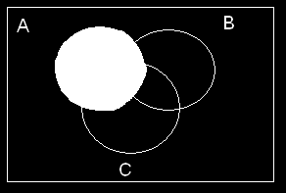

(b)

(c)

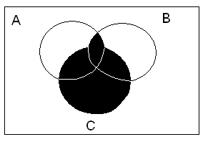

(d)

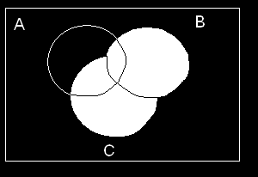

(e)

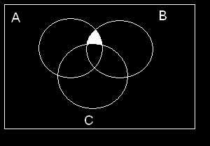

2.1.14 In an injection-molding operation, the length and width, denoted as *X* and *Y* , respectively, of each molded part are evaluated. Let

*A* denote the event of 48 < *X* < 52 centimeters

*B* denote the event of 9 < *Y* < 11 centimeters 

Construct a Venn diagram that includes these events. Shade the areas that represent the following:

(a) *A* (b) *A* ∩ *B* (c) *A*′ ∪ *B* (d) *A* ∩ *B*

(e) If these events were mutually exclusive, how successful would this production operation be? Would the process

produce parts with *X*  50 centimeters and *Y* = 10 centimeters?

(a)

A

B

48

52

11

9

A

B

48

52

11

9

(b)