Chapter 02
Professional Standards

True / False Questions
1. | To express an opinion on financial statements, the auditor obtains reasonable assurance about whether the financial statements as a whole are free from material misstatement, whether due to fraud or error.  True False

2. | The auditors' report on a corporation's financial statements usually is addressed to the president of the company.  True False

3. | The auditors are primarily responsible for preparing the financial statements and expressing an opinion on whether they follow generally accepted auditing standards.  True False

4. | Partners in CPA firms usually have the responsibility for signing the audit report.  True False

5. | An audit is more likely to detect tax evasion than violations of antitrust laws.  True False

6. | The attestation standards do not supersede generally accepted auditing standards.  True False

7. | A peer review is generally performed by employees of the AICPA.  True False

8. | If the auditors discover illegal acts by a client, they ordinarily should immediately resign from the engagement.  True False

9. | An audit should be designed to obtain reasonable assurance of detecting non-compliance with all laws.  True False

10. | The pronouncements of the International Auditing and Assurance Standards Board do not override the national auditing standards of its members, even when financial statements are issued by a multinational company.  True False

Multiple Choice Questions
11. | Audits of financial statements are designed to obtain reasonable assurance of detecting misstatement due to:  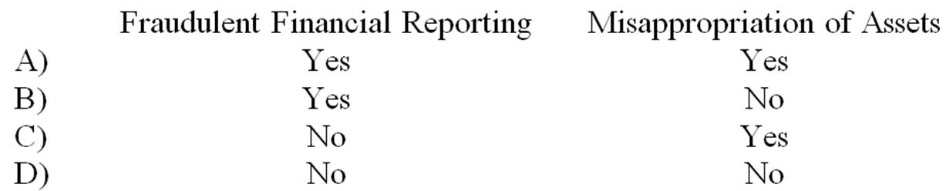  A. Option A.  B. Option B.  C. Option C.  D. Option D.

12. | Financial statements are prepared following a(an)  A. Applicable financial reporting framework.  B. Appropriate subject matter.  C. Generally accepted auditing standards.  D. Set of quality control standards.

13. | An attestation engagement:  A. Has as its primary source of standards the assurance standards.  B. Includes a report on subject matter, or on an assertion about subject matter.  C. Includes search and verification procedures for all major accounts.  D. Is ordinarily an examination, review or compilation engagement.

14. | An audit provides reasonable assurance of detecting which of the following types of material illegal acts?  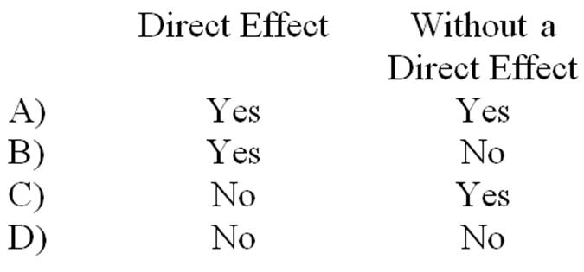  A. Option A.  B. Option B.  C. Option C.  D. Option D.

15. | Which of the following is not a type of auditors' opinion?  A. Adverse.  B. Ordinary.  C. Qualified.  D. Unmodified.

16. | Which of the following is one of the elements of AICPA quality control?  A. Assurance of proper levels of association.  B. Due professional care.  C. Engagement performance.  D. Supervision.

17. | A procedure in which a quality control partner periodically tests the application of quality control procedures is most directly related to which quality control element?  A. Engagement performance.  B. Human resources.  C. Leadership responsibilities for quality with the firm.  D. Monitoring.

18. | Requirements for training, independence and due professional care are included in which group of the generally accepted auditing standards of the PCAOB?  A. Fieldwork.  B. General.  C. Reporting.  D. Quality control.

19. | Which of the following is a principle underlying an audit conducted in accordance with generally accepted auditing standards?  A. The audit provides reasonable assurance the client will remain in business for at least one year.  B. The audit report expresses an opinion on whether the financial statements are free of material and immaterial misstatement.  C. Auditors are responsible for, among other things, maintaining professional objectivism, exercising professional engagement, and obtaining appropriate documentation.  D. An auditor's opinion enhances the degree of confidence that intended users can place in the financial statements.

20. | A set of criteria used to determine measurement, recognition, representation, and disclosure of all material items appearing in the financial statements is referred to as a(n)  A. Financial reporting framework.  B. Quality control presentation standard.  C. Public Company Accounting Oversight Board Criteria.  D. Special purpose audit standard.

21. | An audit should be designed to obtain reasonable assurance of detecting material misstatements due to:  A. Errors.  B. Errors and fraud.  C. Errors, fraud, and noncompliance with laws with a direct effect on financial statement amounts.  D. Errors, fraud and noncompliance with all laws.

22. | Which of the following is accurate, as indicated in the principles underlying an audit?  A. Management is expected to provide the auditors with all needed evidence prior to the beginning of audit work.  B. An auditor is unable to obtain absolute assurance that the financial statements are free from material misstatement.  C. Auditors are responsible for having appropriate competence to perform the audit without the assistance of outside specialists.  D. Management is responsible for preparing accurate financial statement amounts, while auditors are responsible for auditing those amounts and for preparing note disclosures related to those amounts.

23. | Which of the following is not an underlying premise of an audit?  A. Management should provide the auditor with all information relevant to the preparation and fair presentation of the financial statements.  B. Management and the auditors have responsibility for the preparation of financial statements in accordance with the applicable financial reporting framework.  C. Where appropriate, the auditor may obtain information from those charged with governance.  D. The auditors should be provided unrestricted access to those within the entity from whom the auditor determines it necessary to obtain audit evidence.

24. | By definition, proper professional skepticism on an audit requires  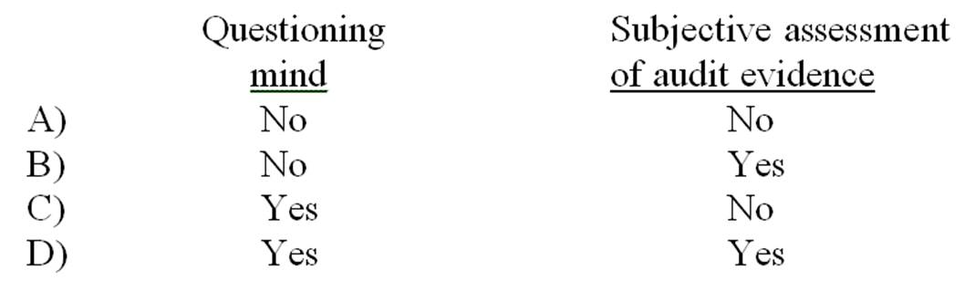  A. Option A.  B. Option B.  C. Option C.  D. Option D.

25. | When a Statement Auditing Standards uses the word "should" relating to a requirement, it means that the auditor:  A. Should fulfill the responsibilities under all circumstances.  B. Should comply with requirements unless the auditor demonstrates and documents that alternative actions are sufficient to achieve the objectives of the standards.  C. Should consider whether to follow the advice based on the exercise of professional judgment in the circumstances.  D. May choose to change responsibilities relating to various professional standards that remain under consideration.

26. | An unconditional responsibility to follow an AICPA professional standard exists when the professional standard uses the term(s)  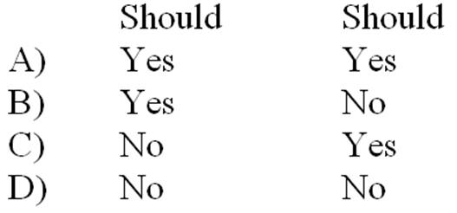  A. Option A.  B. Option B.  C. Option C.  D. Option D.

27. | Which of the following best describes a portion of the auditors' responsibility regarding noncompliance with laws by clients?  A. The auditors have a responsibility to discover all material noncompliance.  B. If audit procedures reveal noncompliance, the auditors should take appropriate actions.  C. If the auditors suspect noncompliance, they should conduct a legal audit of the company.  D. The auditors' responsibility for the detection of all noncompliance is the same as their responsibility regarding material misstatements due to errors and fraud.

28. | The auditors who find that the client has committed an illegal act would be most likely to withdraw from the engagement when the:  A. Management fails to take appropriate corrective action.  B. Illegal act has material financial statement implications.  C. Illegal act has received widespread publicity.  D. Auditors cannot reasonably estimate the effect of the illegal act on the financial statements.

29. | Which of the following is not included as a part of the description of the auditor's responsibility in a nonpublic company unmodified report?  A. The audit was performed in accordance with generally accepted accounting principles.  B. An audit involves performing procedures to obtain audit evidence about the amounts and disclosures in the financial statements.  C. The procedures selected depend on the auditor's judgment.  D. An audit includes evaluating the appropriateness of accounting policies used.

30. | Primary responsibility for the financial statements lies with:  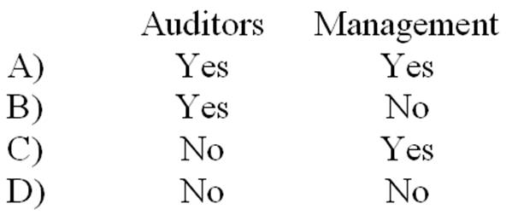  A. Option A.  B. Option B.  C. Option C.  D. Option D.

31. | Which of the following is explicitly included as a part of the description of management's responsibility in an unmodified audit report?  A. Management is responsible for making a judgment on which misstatements are material vs. immaterial.  B. Management is responsible for providing auditors with all relevant evidence.  C. Management is responsible for the design, implementation, and maintenance of internal control.  D. Management is responsible for listing all illegal acts with a direct effect on financial statement amounts and disclosures.

32. | The auditors' report for a nonpublic company should indicate:  A. That the audit was made in accordance with auditing standards generally accepted in the United States of America.  B. Any weakness in internal control observed by the auditors.  C. That accounting principles have been consistently applied.  D. That no illegal acts have been identified.

33. | The Auditing Standards Board's guidance on matters such as the purpose of an audit, the premise of an audit, and auditor personal responsibilities is included in:  A. The 10 Generally Accepted Auditing Standards.  B. The Code of Professional Conduct.  C. Accounting Series Releases.  D. Principles Underlying an Audit Conducted in Accordance with GAAS.

34. | A requirement that working papers be reviewed by the supervisor, and any deficiencies be discussed with the preparer is an example of a quality control procedure in the area of:  A. Acceptance and continuance of client relationships and specific engagements.  B. Engagement performance.  C. Human resources.  D. Relevant ethical requirements.

35. | A requirement to design recruitment processes and procedures to help the firm select individuals meeting minimum academic requirements established by the firm is an example of a quality control procedure in the area of:  A. Acceptance and continuance of client relationships and specific engagements.  B. Engagement performance.  C. Human resources.  D. Relevant ethical requirements.

36. | The body that issues international pronouncements providing auditing procedural and reporting guidance is the:  A. International Federation of Auditors.  B. Multinational Reporting Commission.  C. International Auditing and Assurance Standards Board.  D. AICPA Auditing Standards Board.

37. | To present fairly in conformity with generally accepted accounting principles the financial statements should:  A. Be consistently applied.  B. Inform users of all matters that could materially affect a decision.  C. Reflect transactions and events within a range of reasonable limits.  D. Be considered preferable to the users of those financial statements.

38. | Which of the following is not included in the auditors' standard unmodified audit report?  A. The procedures selected by the auditor depend on the auditor's judgment.  B. An audit includes evaluating the appropriateness of accounting policies used.  C. An audit includes evaluating the overall presentation of the financial statements.  D. Accounting principles have been consistently applied.

39. | An audit performed in accordance with generally accepted auditing standards generally should:  A. Be expected to provide absolute assurance that noncompliance with all laws will be detected where internal control is effective.  B. Be relied upon to disclose violations of truth in lending laws.  C. Encompass a plan to actively search for all illegalities which relate to operating aspects.  D. Not be relied upon to provide absolute assurance that all noncompliance with laws will be detected.

40. | When the auditors express an opinion on financial statements their responsibilities extend to:  A. The underlying wisdom of their client's management decisions.  B. Whether the results of their client's operating decisions are fairly presented in the financial statements.  C. Active participation in the implementation of the advice given to their client.  D. An ongoing responsibility for their client's solvency.

41. | Authoritative GAAP sources include:  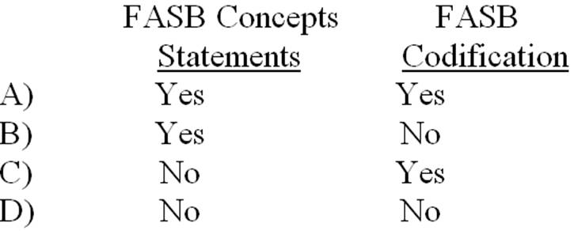  A. Option A.  B. Option B.  C. Option C.  D. Option D.

42. | An investor reading the financial statements of The Sundby Corporation observes that the statements are accompanied by an unmodified auditors' report. From this the investor may conclude that:  A. Any disputes over significant accounting issues have been settled to the auditors' satisfaction.  B. The auditors are satisfied that Sundby is operationally efficient.  C. The auditors have ascertained that Sundby's financial statements have been prepared accurately.  D. Informative disclosures in the financial statements but not necessarily in the footnotes are to be regarded as reasonably adequate.

43. | The auditors' report may be addressed to the company whose financial statements are being examined or to that company's:  A. Chief operating officer.  B. President.  C. Board of Directors.  D. Chief financial officer.

44. | Which of the following best describes what is meant by generally accepted auditing standards?  A. Acts to be performed by the auditors.  B. Measures of the quality of the auditors' performance.  C. Procedures to be used to gather evidence to support financial statements.  D. Audit objectives generally determined on audit engagements.

45. | If noncompliance with a law is discovered during the audit of a publicly held company, the auditors should first:  A. Notify the regulatory authorities.  B. Determine who was responsible for the noncompliance.  C. Intensify the examination to identify noncompliance with any laws.  D. Report the act to high level personnel within the client's organization and to the audit committee.

46. | Which of the following is the name used to describe financial reporting frameworks other than GAAP which include: cash basis, tax basis, regulatory basis, or contractual basis?  A. Applicable.  B. PCAOB.  C. Special reports.  D. Special purpose.

47. | Which of the following statements best describes the primary purpose of Statements on Auditing Standards?  A. They are guides intended to set forth auditing procedures which are applicable to a variety of situations.  B. They are procedural outlines which are intended to narrow the areas of inconsistency and divergence of auditor opinion.  C. They are authoritative statements, enforced through the Code of Professional Conduct.  D. They are interpretations which may be useful guidance to auditors.

48. | The primary responsibility for the adequacy of disclosure in the financial statements of a publicly held company rests with the:  A. Partner assigned to the audit engagement.  B. Management of the company.  C. Auditor in charge of the fieldwork.  D. Securities and Exchange Commission.

49. | Within the context of quality control, the primary purpose of continuing professional education and training activities is to enable a CPA firm to provide personnel within the firm with:  A. Technical training that assures proficiency as an auditor.  B. Professional education that is required in order to perform with due professional care.  C. Knowledge required to fulfill assigned responsibilities and to progress within the firm.  D. Knowledge required in order to perform a peer review.

50. | In pursuing a CPA firm's quality control objectives, a CPA firm may maintain records indicating which partners or employees of the CPA firm were previously employed by the CPA firm's clients. Which quality control objective would this be most likely to satisfy?  A. Acceptance and continuance of clients and engagements.  B. Engagement performance.  C. Personnel management.  D. Relevant ethical requirements.

51. | A CPA firm establishes quality control policies and procedures for deciding whether to accept a new client or continue to perform services for a current client. The primary purpose for establishing such policies and procedures is:  A. To enable the auditor to attest to the integrity or reliability of a client.  B. To comply with the quality control standards established by regulatory bodies.  C. To minimize the likelihood of association with clients whose managements lack integrity.  D. To lessen the exposure to litigation resulting from failure to detect fraud in client financial statements.

52. | Which of the following is not an element of quality control?  A. Documentation.  B. Engagement performance.  C. Monitoring.  D. Relevant ethical requirements.

53. | Generally accepted auditing standards established by the AICPA through April of 2003:  A. Have been accepted as interim standards by the Public Company Accounting Oversight Board.  B. Provide accounting guidance for nonpublic companies.  C. Have all been superseded by Public Company Accounting Oversight Board standards.  D. Are now developed by the Securities and Exchange Commission.

54. | The Public Company Accounting Oversight Board has authority to establish which of the following relating to public companies?  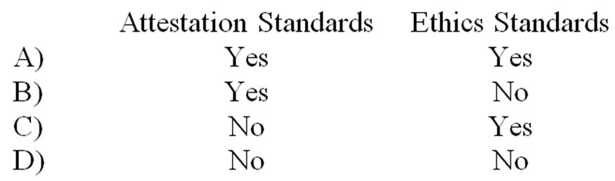  A. Option A.  B. Option B.  C. Option C.  D. Option D.

55. | Which of the following is least likely to be directly examined in an inspection performed by the PCAOB?  A. Audit engagements.  B. Review engagements.  C. Compilation engagements.  D. CPA firm quality control system.

56. | As compared with the US public company audit report, the international audit report:  A. Is shorter in length.  B. Includes enhanced explanation of the audit process.  C. Includes the name of the partner and managers on the audit, while the US report includes only the CPA firm name.  D. Is dated as of year-end, whereas the US report is dated as of the last date of significant field work.

57. | A peer review in which the peer reviewers study and appraise a CPA firm's system of quality control to perform accounting and auditing work is referred to as a(n):  A. Engagement review.  B. Inspection review.  C. Supervision review.  D. System review.

58. | An engagement review form of peer review is least likely to include a peer reviewer's detailed analysis of:  A. Compilation reports.  B. Documentation of procedures followed on a review.  C. Overall system of quality control.  D. Review reports.

59. | Of the following, which are current types of peer review?  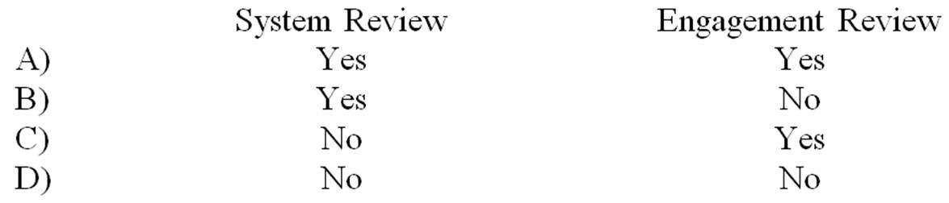  A. Option A.  B. Option B.  C. Option C.  D. Option D.

Short Answer Questions
60. | Indicate whether you agree or disagree with the following statements concerning a financial statement audit conducted in accordance with generally accepted auditing standards.  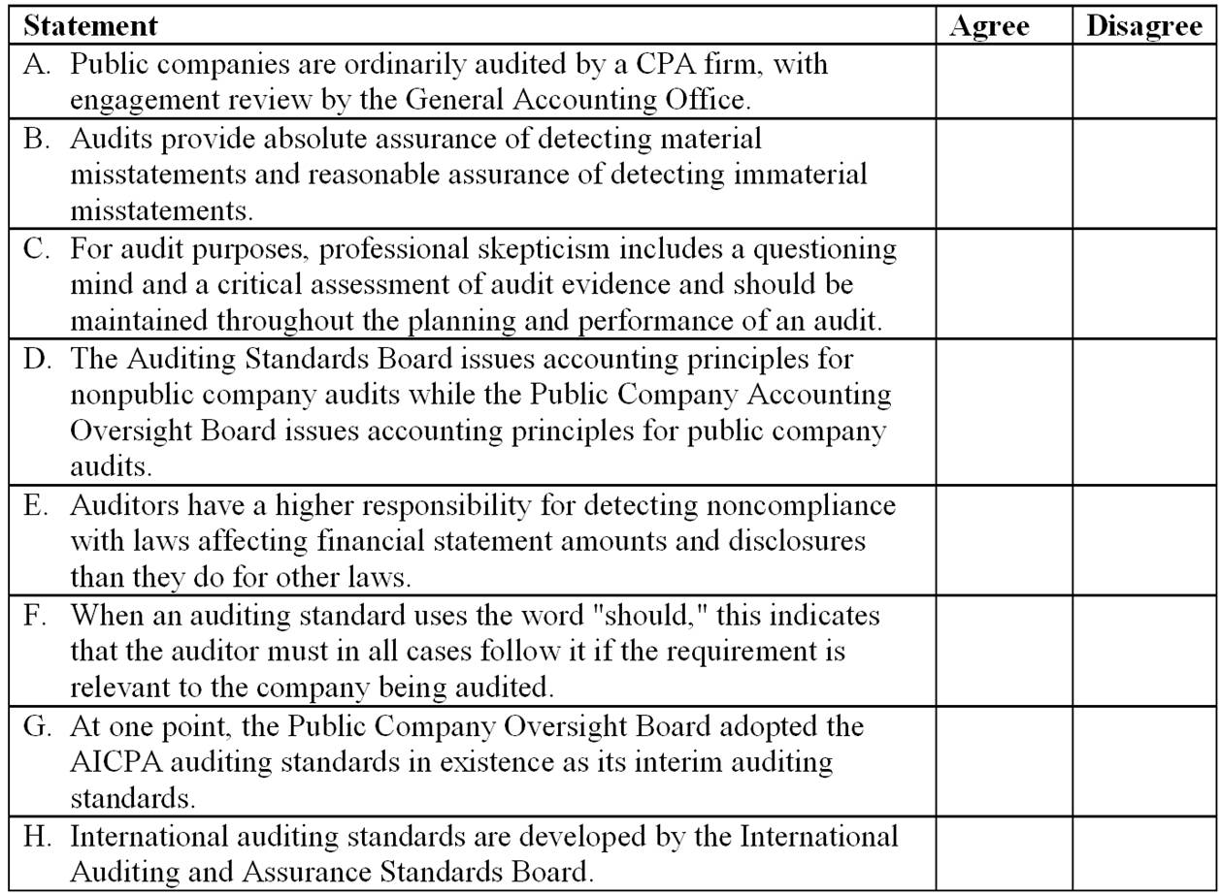

Essay Questions
61. | The standard unmodified auditors' report for audits of nonpublic companies consists of three paragraphs. Identify the three paragraphs and describe the purpose of each.

62. | Auditors must consider the possibility of fraud by employees or management on every audit engagement. They must also consider the possibility that the client has not complied with laws.  (a) Distinguish between employee and management fraud.  (b) Describe the auditors' responsibility for the detection of fraud in an audit.  (c) Describe the auditors' responsibility regarding noncompliance with laws by a client.

Chapter 02 Professional Standards Answer Key

True / False Questions
1. | To express an opinion on financial statements, the auditor obtains reasonable assurance about whether the financial statements as a whole are free from material misstatement, whether due to fraud or error.  TRUE

AACSB: Analytic
AICPA BB: Industry
AICPA FN: Decision Making
Blooms: Remember
Difficulty: 1 Easy
Learning Objective: 02-03 Discuss the auditors responsibility for detecting errors; fraud; and noncompliance with laws and regulations.
Topic: Detecting Misstatements

2. | The auditors' report on a corporation's financial statements usually is addressed to the president of the company.  FALSE

AACSB: Communication
AICPA BB: Industry
AICPA FN: Reporting
Blooms: Remember
Difficulty: 1 Easy
Learning Objective: 02-04 Explain the key elements of the auditors standard report.
Topic: Auditors' Reports

3. | The auditors are primarily responsible for preparing the financial statements and expressing an opinion on whether they follow generally accepted auditing standards.  FALSE

AACSB: Communication
AICPA BB: Industry
AICPA FN: Reporting
Blooms: Remember
Difficulty: 2 Medium
Learning Objective: 02-04 Explain the key elements of the auditors standard report.
Topic: Auditors' Reports

4. | Partners in CPA firms usually have the responsibility for signing the audit report.  TRUE

AACSB: Communication
AICPA BB: Industry
AICPA FN: Reporting
Blooms: Remember
Difficulty: 2 Medium
Learning Objective: 02-04 Explain the key elements of the auditors standard report.
Topic: Auditors' Reports

5. | An audit is more likely to detect tax evasion than violations of antitrust laws.  TRUE

AACSB: Communication
AICPA BB: Critical Thinking
AICPA FN: Reporting
Blooms: Understand
Difficulty: 3 Hard
Learning Objective: 02-04 Explain the key elements of the auditors standard report.
Topic: Auditors' Reports

6. | The attestation standards do not supersede generally accepted auditing standards.  TRUE

AACSB: Analytic
AICPA BB: Industry
AICPA FN: Decision Making
Blooms: Remember
Difficulty: 2 Medium
Learning Objective: 02-06 Describe the attestation standards.
Topic: Attestation Standards

7. | A peer review is generally performed by employees of the AICPA.  FALSE

AACSB: Analytic
AICPA BB: Industry
AICPA FN: Decision Making
Blooms: Remember
Difficulty: 2 Medium
Learning Objective: 02-07 Describe the quality control standards and their purposes.
Topic: Quality Control

8. | If the auditors discover illegal acts by a client, they ordinarily should immediately resign from the engagement.  FALSE

AACSB: Analytic
AICPA BB: Industry
AICPA FN: Decision Making
Blooms: Remember
Difficulty: 2 Medium
Learning Objective: 02-03 Discuss the auditors responsibility for detecting errors; fraud; and noncompliance with laws and regulations.
Topic: Detecting Misstatements

9. | An audit should be designed to obtain reasonable assurance of detecting non-compliance with all laws.  FALSE

AACSB: Analytic
AICPA BB: Industry
AICPA FN: Decision Making
Blooms: Remember
Difficulty: 2 Medium
Learning Objective: 02-02 Identify the nature and underlying principles of generally accepted auditing standards.
Topic: Auditing Standards

10. | The pronouncements of the International Auditing and Assurance Standards Board do not override the national auditing standards of its members, even when financial statements are issued by a multinational company.  TRUE

AACSB: Communication
AACSB: Diversity
AICPA BB: Global
AICPA BB: Industry
AICPA FN: Decision Making
AICPA FN: Reporting
Blooms: Remember
Difficulty: 2 Medium
Learning Objective: 02-08 Explain the status of international accounting and auditing standards and the content of the international audit report.
Topic: International Standards

Multiple Choice Questions
11. | Audits of financial statements are designed to obtain reasonable assurance of detecting misstatement due to:  A. Option A.  B. Option B.  C. Option C.  D. Option D.

AACSB: Reflective Thinking
AICPA BB: Critical Thinking
AICPA FN: Decision Making
Blooms: Understand
Difficulty: 3 Hard
Learning Objective: 02-03 Discuss the auditors responsibility for detecting errors; fraud; and noncompliance with laws and regulations.
Topic: Detecting Misstatements

12. | Financial statements are prepared following a(an)  A. Applicable financial reporting framework.  B. Appropriate subject matter.  C. Generally accepted auditing standards.  D. Set of quality control standards.

AACSB: Analytic
AICPA BB: Industry
AICPA FN: Decision Making
Blooms: Remember
Difficulty: 2 Medium
Learning Objective: 02-02 Identify the nature and underlying principles of generally accepted auditing standards.
Topic: Auditing Standards

13. | An attestation engagement:  A. Has as its primary source of standards the assurance standards.  B. Includes a report on subject matter, or on an assertion about subject matter.  C. Includes search and verification procedures for all major accounts.  D. Is ordinarily an examination, review or compilation engagement.

AACSB: Reflective Thinking
AICPA BB: Critical Thinking
AICPA FN: Decision Making
Blooms: Understand
Difficulty: 3 Hard
Learning Objective: 02-06 Describe the attestation standards.
Topic: Attestation Standards

14. | An audit provides reasonable assurance of detecting which of the following types of material illegal acts?  A. Option A.  B. Option B.  C. Option C.  D. Option D.

AACSB: Analytic
AICPA BB: Industry
AICPA FN: Decision Making
Blooms: Remember
Difficulty: 2 Medium
Learning Objective: 02-03 Discuss the auditors responsibility for detecting errors; fraud; and noncompliance with laws and regulations.
Topic: Detecting Misstatements

15. | Which of the following is not a type of auditors' opinion?  A. Adverse.  B. Ordinary.  C. Qualified.  D. Unmodified.

AACSB: Communication
AACSB: Reflective Thinking
AICPA BB: Industry
AICPA FN: Reporting
Blooms: Understand
Difficulty: 2 Medium
Learning Objective: 02-04 Explain the key elements of the auditors standard report.
Learning Objective: 02-05 Discuss the other types of reports that are issued by auditors.
Topic: Auditors' Reports

16. | Which of the following is one of the elements of AICPA quality control?  A. Assurance of proper levels of association.  B. Due professional care.  C. Engagement performance.  D. Supervision.

AACSB: Reflective Thinking
AICPA BB: Critical Thinking
AICPA FN: Decision Making
Blooms: Understand
Difficulty: 3 Hard
Learning Objective: 02-07 Describe the quality control standards and their purposes.
Topic: Quality Control

17. | A procedure in which a quality control partner periodically tests the application of quality control procedures is most directly related to which quality control element?  A. Engagement performance.  B. Human resources.  C. Leadership responsibilities for quality with the firm.  D. Monitoring.

AACSB: Reflective Thinking
AICPA BB: Critical Thinking
AICPA FN: Decision Making
Blooms: Understand
Difficulty: 3 Hard
Learning Objective: 02-07 Describe the quality control standards and their purposes.
Topic: Quality Control

18. | Requirements for training, independence and due professional care are included in which group of the generally accepted auditing standards of the PCAOB?  A. Fieldwork.  B. General.  C. Reporting.  D. Quality control.

AACSB: Analytic
AICPA BB: Industry
AICPA FN: Decision Making
Blooms: Remember
Difficulty: 2 Medium
Learning Objective: 02-02 Identify the nature and underlying principles of generally accepted auditing standards.
Topic: Auditing Standards

19. | Which of the following is a principle underlying an audit conducted in accordance with generally accepted auditing standards?  A. The audit provides reasonable assurance the client will remain in business for at least one year.  B. The audit report expresses an opinion on whether the financial statements are free of material and immaterial misstatement.  C. Auditors are responsible for, among other things, maintaining professional objectivism, exercising professional engagement, and obtaining appropriate documentation.  D. An auditor's opinion enhances the degree of confidence that intended users can place in the financial statements.

AACSB: Reflective Thinking
AICPA BB: Critical Thinking
AICPA FN: Decision Making
Blooms: Understand
Difficulty: 3 Hard
Learning Objective: 02-04 Explain the key elements of the auditors standard report.
Topic: Auditors' Reports

20. | A set of criteria used to determine measurement, recognition, representation, and disclosure of all material items appearing in the financial statements is referred to as a(n)  A. Financial reporting framework.  B. Quality control presentation standard.  C. Public Company Accounting Oversight Board Criteria.  D. Special purpose audit standard.

AACSB: Analytic
AICPA BB: Industry
AICPA FN: Decision Making
Blooms: Remember
Difficulty: 1 Easy
Learning Objective: 02-02 Identify the nature and underlying principles of generally accepted auditing standards.
Topic: Auditing Standards

21. | An audit should be designed to obtain reasonable assurance of detecting material misstatements due to:  A. Errors.  B. Errors and fraud.  C. Errors, fraud, and noncompliance with laws with a direct effect on financial statement amounts.  D. Errors, fraud and noncompliance with all laws.

AACSB: Reflective Thinking
AICPA BB: Critical Thinking
AICPA FN: Decision Making
Blooms: Understand
Difficulty: 3 Hard
Learning Objective: 02-03 Discuss the auditors responsibility for detecting errors; fraud; and noncompliance with laws and regulations.
Topic: Detecting Misstatements

22. | Which of the following is accurate, as indicated in the principles underlying an audit?  A. Management is expected to provide the auditors with all needed evidence prior to the beginning of audit work.  B. An auditor is unable to obtain absolute assurance that the financial statements are free from material misstatement.  C. Auditors are responsible for having appropriate competence to perform the audit without the assistance of outside specialists.  D. Management is responsible for preparing accurate financial statement amounts, while auditors are responsible for auditing those amounts and for preparing note disclosures related to those amounts.

AACSB: Analytic
AICPA BB: Industry
AICPA FN: Decision Making
Blooms: Remember
Difficulty: 2 Medium
Learning Objective: 02-02 Identify the nature and underlying principles of generally accepted auditing standards.
Topic: Auditing Standards

23. | Which of the following is not an underlying premise of an audit?  A. Management should provide the auditor with all information relevant to the preparation and fair presentation of the financial statements.  B. Management and the auditors have responsibility for the preparation of financial statements in accordance with the applicable financial reporting framework.  C. Where appropriate, the auditor may obtain information from those charged with governance.  D. The auditors should be provided unrestricted access to those within the entity from whom the auditor determines it necessary to obtain audit evidence.

AACSB: Communication
AICPA BB: Critical Thinking
AICPA FN: Reporting
Blooms: Understand
Difficulty: 3 Hard
Learning Objective: 02-04 Explain the key elements of the auditors standard report.
Topic: Auditors' Reports

24. | By definition, proper professional skepticism on an audit requires  A. Option A.  B. Option B.  C. Option C.  D. Option D.

AACSB: Reflective Thinking
AICPA BB: Critical Thinking
AICPA FN: Decision Making
Blooms: Understand
Difficulty: 3 Hard
Learning Objective: 02-02 Identify the nature and underlying principles of generally accepted auditing standards.
Topic: Auditing Standards

25. | When a Statement Auditing Standards uses the word "should" relating to a requirement, it means that the auditor:  A. Should fulfill the responsibilities under all circumstances.  B. Should comply with requirements unless the auditor demonstrates and documents that alternative actions are sufficient to achieve the objectives of the standards.  C. Should consider whether to follow the advice based on the exercise of professional judgment in the circumstances.  D. May choose to change responsibilities relating to various professional standards that remain under consideration.

AACSB: Reflective Thinking
AICPA BB: Critical Thinking
AICPA FN: Decision Making
Blooms: Understand
Difficulty: 3 Hard
Learning Objective: 02-02 Identify the nature and underlying principles of generally accepted auditing standards.
Topic: Auditing Standards

26. | An unconditional responsibility to follow an AICPA professional standard exists when the professional standard uses the term(s)  A. Option A.  B. Option B.  C. Option C.  D. Option D.

AACSB: Analytic
AICPA BB: Industry
AICPA FN: Decision Making
Blooms: Remember
Difficulty: 2 Medium
Learning Objective: 02-02 Identify the nature and underlying principles of generally accepted auditing standards.
Topic: Auditing Standards

27. | Which of the following best describes a portion of the auditors' responsibility regarding noncompliance with laws by clients?  A. The auditors have a responsibility to discover all material noncompliance.  B. If audit procedures reveal noncompliance, the auditors should take appropriate actions.  C. If the auditors suspect noncompliance, they should conduct a legal audit of the company.  D. The auditors' responsibility for the detection of all noncompliance is the same as their responsibility regarding material misstatements due to errors and fraud.

AACSB: Analytic
AICPA BB: Industry
AICPA FN: Decision Making
Blooms: Remember
Difficulty: 2 Medium
Learning Objective: 02-03 Discuss the auditors responsibility for detecting errors; fraud; and noncompliance with laws and regulations.
Topic: Detecting Misstatements

28. | The auditors who find that the client has committed an illegal act would be most likely to withdraw from the engagement when the:  A. Management fails to take appropriate corrective action.  B. Illegal act has material financial statement implications.  C. Illegal act has received widespread publicity.  D. Auditors cannot reasonably estimate the effect of the illegal act on the financial statements.

AACSB: Analytic
AICPA BB: Industry
AICPA FN: Decision Making
Blooms: Remember
Difficulty: 2 Medium
Learning Objective: 02-03 Discuss the auditors responsibility for detecting errors; fraud; and noncompliance with laws and regulations.
Topic: Detecting Misstatements

29. | Which of the following is not included as a part of the description of the auditor's responsibility in a nonpublic company unmodified report?  A. The audit was performed in accordance with generally accepted accounting principles.  B. An audit involves performing procedures to obtain audit evidence about the amounts and disclosures in the financial statements.  C. The procedures selected depend on the auditor's judgment.  D. An audit includes evaluating the appropriateness of accounting policies used.

AACSB: Communication
AICPA BB: Industry
AICPA FN: Reporting
Blooms: Remember
Difficulty: 2 Medium
Learning Objective: 02-04 Explain the key elements of the auditors standard report.
Topic: Auditors' Reports

30. | Primary responsibility for the financial statements lies with:  A. Option A.  B. Option B.  C. Option C.  D. Option D.

AACSB: Communication
AICPA BB: Industry
AICPA FN: Reporting
Blooms: Remember
Difficulty: 2 Medium
Learning Objective: 02-04 Explain the key elements of the auditors standard report.
Topic: Auditors' Reports

31. | Which of the following is explicitly included as a part of the description of management's responsibility in an unmodified audit report?  A. Management is responsible for making a judgment on which misstatements are material vs. immaterial.  B. Management is responsible for providing auditors with all relevant evidence.  C. Management is responsible for the design, implementation, and maintenance of internal control.  D. Management is responsible for listing all illegal acts with a direct effect on financial statement amounts and disclosures.

AACSB: Analytic
AICPA BB: Industry
AICPA FN: Decision Making
Blooms: Remember
Difficulty: 2 Medium
Learning Objective: 02-02 Identify the nature and underlying principles of generally accepted auditing standards.
Topic: Auditing Standards

32. | The auditors' report for a nonpublic company should indicate:  A. That the audit was made in accordance with auditing standards generally accepted in the United States of America.  B. Any weakness in internal control observed by the auditors.  C. That accounting principles have been consistently applied.  D. That no illegal acts have been identified.

AACSB: Analytic
AICPA BB: Industry
AICPA FN: Decision Making
Blooms: Remember
Difficulty: 2 Medium
Learning Objective: 02-02 Identify the nature and underlying principles of generally accepted auditing standards.
Topic: Auditing Standards

33. | The Auditing Standards Board's guidance on matters such as the purpose of an audit, the premise of an audit, and auditor personal responsibilities is included in:  A. The 10 Generally Accepted Auditing Standards.  B. The Code of Professional Conduct.  C. Accounting Series Releases.  D. Principles Underlying an Audit Conducted in Accordance with GAAS.

AACSB: Analytic
AICPA BB: Industry
AICPA FN: Decision Making
Difficulty: 2 Medium
Learning Objective: 02-02 Identify the nature and underlying principles of generally accepted auditing standards.
Topic: Auditing Standards

34. | A requirement that working papers be reviewed by the supervisor, and any deficiencies be discussed with the preparer is an example of a quality control procedure in the area of:  A. Acceptance and continuance of client relationships and specific engagements.  B. Engagement performance.  C. Human resources.  D. Relevant ethical requirements.

AACSB: Reflective Thinking
AICPA BB: Critical Thinking
AICPA FN: Decision Making
Blooms: Understand
Difficulty: 3 Hard
Learning Objective: 02-07 Describe the quality control standards and their purposes.
Topic: Quality Control

35. | A requirement to design recruitment processes and procedures to help the firm select individuals meeting minimum academic requirements established by the firm is an example of a quality control procedure in the area of:  A. Acceptance and continuance of client relationships and specific engagements.  B. Engagement performance.  C. Human resources.  D. Relevant ethical requirements.

AACSB: Reflective Thinking
AICPA BB: Critical Thinking
AICPA FN: Decision Making
Blooms: Understand
Difficulty: 3 Hard
Learning Objective: 02-07 Describe the quality control standards and their purposes.
Topic: Quality Control

36. | The body that issues international pronouncements providing auditing procedural and reporting guidance is the:  A. International Federation of Auditors.  B. Multinational Reporting Commission.  C. International Auditing and Assurance Standards Board.  D. AICPA Auditing Standards Board.

AACSB: Communication
AACSB: Diversity
AICPA BB: Global
AICPA BB: Industry
AICPA FN: Decision Making
AICPA FN: Reporting
Difficulty: 2 Medium
Learning Objective: 02-08 Explain the status of international accounting and auditing standards and the content of the international audit report.
Topic: International Standards

37. | To present fairly in conformity with generally accepted accounting principles the financial statements should:  A. Be consistently applied.  B. Inform users of all matters that could materially affect a decision.  C. Reflect transactions and events within a range of reasonable limits.  D. Be considered preferable to the users of those financial statements.

AACSB: Analytic
AICPA BB: Industry
AICPA FN: Decision Making
Blooms: Remember
Difficulty: 2 Medium
Learning Objective: 02-02 Identify the nature and underlying principles of generally accepted auditing standards.
Topic: Auditing Standards

38. | Which of the following is not included in the auditors' standard unmodified audit report?  A. The procedures selected by the auditor depend on the auditor's judgment.  B. An audit includes evaluating the appropriateness of accounting policies used.  C. An audit includes evaluating the overall presentation of the financial statements.  D. Accounting principles have been consistently applied.

AACSB: Communication
AICPA BB: Industry
AICPA FN: Reporting
Blooms: Remember
Difficulty: 2 Medium
Learning Objective: 02-04 Explain the key elements of the auditors standard report.
Topic: Auditors' Reports

39. | An audit performed in accordance with generally accepted auditing standards generally should:  A. Be expected to provide absolute assurance that noncompliance with all laws will be detected where internal control is effective.  B. Be relied upon to disclose violations of truth in lending laws.  C. Encompass a plan to actively search for all illegalities which relate to operating aspects.  D. Not be relied upon to provide absolute assurance that all noncompliance with laws will be detected.

AACSB: Analytic
AICPA BB: Industry
AICPA FN: Reporting
Blooms: Remember
Difficulty: 2 Medium
Learning Objective: 02-02 Identify the nature and underlying principles of generally accepted auditing standards.
Source: AICPA
Topic: Auditing Standards

40. | When the auditors express an opinion on financial statements their responsibilities extend to:  A. The underlying wisdom of their client's management decisions.  B. Whether the results of their client's operating decisions are fairly presented in the financial statements.  C. Active participation in the implementation of the advice given to their client.  D. An ongoing responsibility for their client's solvency.

AACSB: Communication
AICPA BB: Industry
AICPA FN: Reporting
Blooms: Remember
Difficulty: 2 Medium
Learning Objective: 02-04 Explain the key elements of the auditors standard report.
Source: AICPA
Topic: Auditors' Reports

41. | Authoritative GAAP sources include:  A. Option A.  B. Option B.  C. Option C.  D. Option D.

AACSB: Communication
AICPA BB: Critical Thinking
AICPA FN: Reporting
Blooms: Understand
Difficulty: 3 Hard
Learning Objective: 02-04 Explain the key elements of the auditors standard report.
Topic: Auditors' Reports

42. | An investor reading the financial statements of The Sundby Corporation observes that the statements are accompanied by an unmodified auditors' report. From this the investor may conclude that:  A. Any disputes over significant accounting issues have been settled to the auditors' satisfaction.  B. The auditors are satisfied that Sundby is operationally efficient.  C. The auditors have ascertained that Sundby's financial statements have been prepared accurately.  D. Informative disclosures in the financial statements but not necessarily in the footnotes are to be regarded as reasonably adequate.

AACSB: Communication
AICPA BB: Critical Thinking
AICPA FN: Reporting
Blooms: Understand
Difficulty: 3 Hard
Learning Objective: 02-04 Explain the key elements of the auditors standard report.
Source: AICPA
Topic: Auditors' Reports

43. | The auditors' report may be addressed to the company whose financial statements are being examined or to that company's:  A. Chief operating officer.  B. President.  C. Board of Directors.  D. Chief financial officer.

AACSB: Communication
AICPA BB: Industry
AICPA FN: Reporting
Blooms: Remember
Difficulty: 2 Medium
Learning Objective: 02-04 Explain the key elements of the auditors standard report.
Source: AICPA
Topic: Auditors' Reports

44. | Which of the following best describes what is meant by generally accepted auditing standards?  A. Acts to be performed by the auditors.  B. Measures of the quality of the auditors' performance.  C. Procedures to be used to gather evidence to support financial statements.  D. Audit objectives generally determined on audit engagements.

AACSB: Analytic
AICPA BB: Industry
AICPA FN: Decision Making
Blooms: Remember
Difficulty: 2 Medium
Learning Objective: 02-02 Identify the nature and underlying principles of generally accepted auditing standards.
Source: AICPA
Topic: Auditing Standards

45. | If noncompliance with a law is discovered during the audit of a publicly held company, the auditors should first:  A. Notify the regulatory authorities.  B. Determine who was responsible for the noncompliance.  C. Intensify the examination to identify noncompliance with any laws.  D. Report the act to high level personnel within the client's organization and to the audit committee.

AACSB: Reflective Thinking
AICPA BB: Critical Thinking
AICPA FN: Decision Making
Blooms: Understand
Difficulty: 3 Hard
Learning Objective: 02-03 Discuss the auditors responsibility for detecting errors; fraud; and noncompliance with laws and regulations.
Source: AICPA
Topic: Detecting Misstatements

46. | Which of the following is the name used to describe financial reporting frameworks other than GAAP which include: cash basis, tax basis, regulatory basis, or contractual basis?  A. Applicable.  B. PCAOB.  C. Special reports.  D. Special purpose.

AACSB: Analytic
AICPA BB: Industry
AICPA FN: Decision Making
Blooms: Remember
Difficulty: 1 Easy
Learning Objective: 02-02 Identify the nature and underlying principles of generally accepted auditing standards.
Source: AICPA
Topic: Auditing Standards

47. | Which of the following statements best describes the primary purpose of Statements on Auditing Standards?  A. They are guides intended to set forth auditing procedures which are applicable to a variety of situations.  B. They are procedural outlines which are intended to narrow the areas of inconsistency and divergence of auditor opinion.  C. They are authoritative statements, enforced through the Code of Professional Conduct.  D. They are interpretations which may be useful guidance to auditors.

AACSB: Reflective Thinking
AICPA BB: Industry
AICPA FN: Decision Making
Blooms: Understand
Difficulty: 2 Medium
Learning Objective: 02-02 Identify the nature and underlying principles of generally accepted auditing standards.
Source: AICPA
Topic: Auditing Standards

48. | The primary responsibility for the adequacy of disclosure in the financial statements of a publicly held company rests with the:  A. Partner assigned to the audit engagement.  B. Management of the company.  C. Auditor in charge of the fieldwork.  D. Securities and Exchange Commission.

AACSB: Communication
AICPA BB: Industry
AICPA FN: Reporting
Blooms: Remember
Difficulty: 1 Easy
Learning Objective: 02-04 Explain the key elements of the auditors standard report.
Source: AICPA
Topic: Auditors' Reports

49. | Within the context of quality control, the primary purpose of continuing professional education and training activities is to enable a CPA firm to provide personnel within the firm with:  A. Technical training that assures proficiency as an auditor.  B. Professional education that is required in order to perform with due professional care.  C. Knowledge required to fulfill assigned responsibilities and to progress within the firm.  D. Knowledge required in order to perform a peer review.

AACSB: Reflective Thinking
AICPA BB: Critical Thinking
AICPA FN: Decision Making
Blooms: Understand
Difficulty: 3 Hard
Learning Objective: 02-07 Describe the quality control standards and their purposes.
Source: AICPA
Topic: Quality Control

50. | In pursuing a CPA firm's quality control objectives, a CPA firm may maintain records indicating which partners or employees of the CPA firm were previously employed by the CPA firm's clients. Which quality control objective would this be most likely to satisfy?  A. Acceptance and continuance of clients and engagements.  B. Engagement performance.  C. Personnel management.  D. Relevant ethical requirements.

AACSB: Reflective Thinking
AICPA BB: Critical Thinking
AICPA FN: Decision Making
Blooms: Understand
Difficulty: 3 Hard
Learning Objective: 02-07 Describe the quality control standards and their purposes.
Source: AICPA
Topic: Quality Control

51. | A CPA firm establishes quality control policies and procedures for deciding whether to accept a new client or continue to perform services for a current client. The primary purpose for establishing such policies and procedures is:  A. To enable the auditor to attest to the integrity or reliability of a client.  B. To comply with the quality control standards established by regulatory bodies.  C. To minimize the likelihood of association with clients whose managements lack integrity.  D. To lessen the exposure to litigation resulting from failure to detect fraud in client financial statements.

AACSB: Reflective Thinking
AICPA BB: Industry
AICPA FN: Decision Making
Difficulty: 2 Medium
Learning Objective: 02-07 Describe the quality control standards and their purposes.
Source: AICPA
Topic: Quality Control

52. | Which of the following is not an element of quality control?  A. Documentation.  B. Engagement performance.  C. Monitoring.  D. Relevant ethical requirements.

AACSB: Analytic
AICPA BB: Industry
AICPA FN: Decision Making
Blooms: Remember
Difficulty: 2 Medium
Learning Objective: 02-07 Describe the quality control standards and their purposes.
Source: AICPA
Topic: Quality Control

53. | Generally accepted auditing standards established by the AICPA through April of 2003:  A. Have been accepted as interim standards by the Public Company Accounting Oversight Board.  B. Provide accounting guidance for nonpublic companies.  C. Have all been superseded by Public Company Accounting Oversight Board standards.  D. Are now developed by the Securities and Exchange Commission.

AACSB: Reflective Thinking
AICPA BB: Industry
AICPA FN: Decision Making
Blooms: Understand
Difficulty: 2 Medium
Learning Objective: 02-02 Identify the nature and underlying principles of generally accepted auditing standards.
Topic: Auditing Standards

54. | The Public Company Accounting Oversight Board has authority to establish which of the following relating to public companies?  A. Option A.  B. Option B.  C. Option C.  D. Option D.

AACSB: Reflective Thinking
AICPA BB: Critical Thinking
AICPA FN: Decision Making
Blooms: Understand
Difficulty: 3 Hard
Learning Objective: 02-01 Describe the authority of the two types of auditing standards in effect in the United States-AICPA generally accepted auditing standards and PCAOB standards.
Learning Objective: 02-06 Describe the attestation standards.
Topic: Attestation Standards
Topic: Auditing Standards

55. | Which of the following is least likely to be directly examined in an inspection performed by the PCAOB?  A. Audit engagements.  B. Review engagements.  C. Compilation engagements.  D. CPA firm quality control system.

AACSB: Reflective Thinking
AICPA BB: Industry
AICPA FN: Decision Making
Blooms: Understand
Difficulty: 2 Medium
Learning Objective: 02-07 Describe the quality control standards and their purposes.
Topic: Quality Control

56. | As compared with the US public company audit report, the international audit report:  A. Is shorter in length.  B. Includes enhanced explanation of the audit process.  C. Includes the name of the partner and managers on the audit, while the US report includes only the CPA firm name.  D. Is dated as of year-end, whereas the US report is dated as of the last date of significant field work.

AACSB: Reflective Thinking
AICPA BB: Critical Thinking
AICPA BB: Global
AICPA FN: Decision Making
AICPA FN: Reporting
Blooms: Understand
Difficulty: 3 Hard
Learning Objective: 02-08 Explain the status of international accounting and auditing standards and the content of the international audit report.
Topic: International Standards

57. | A peer review in which the peer reviewers study and appraise a CPA firm's system of quality control to perform accounting and auditing work is referred to as a(n):  A. Engagement review.  B. Inspection review.  C. Supervision review.  D. System review.

AACSB: Reflective Thinking
AICPA BB: Critical Thinking
AICPA FN: Decision Making
Difficulty: 3 Hard
Learning Objective: 02-07 Describe the quality control standards and their purposes.
Topic: Quality Control

58. | An engagement review form of peer review is least likely to include a peer reviewer's detailed analysis of:  A. Compilation reports.  B. Documentation of procedures followed on a review.  C. Overall system of quality control.  D. Review reports.

AACSB: Reflective Thinking
AICPA BB: Critical Thinking
AICPA FN: Decision Making
Blooms: Understand
Difficulty: 3 Hard
Learning Objective: 02-07 Describe the quality control standards and their purposes.
Topic: Quality Control

59. | Of the following, which are current types of peer review?  A. Option A.  B. Option B.  C. Option C.  D. Option D.

AACSB: Reflective Thinking
AICPA BB: Industry
AICPA FN: Decision Making
Blooms: Understand
Difficulty: 2 Medium
Learning Objective: 02-07 Describe the quality control standards and their purposes.
Topic: Quality Control

Short Answer Questions
60. | Indicate whether you agree or disagree with the following statements concerning a financial statement audit conducted in accordance with generally accepted auditing standards.  A. Disagree  B. Disagree  C. Agree  D. Disagree (auditing standards, not accounting principles)  E. Agree  F. Disagree  G. Agree  H. Agree

AACSB: Communication
AACSB: Diversity
AACSB: Reflective Thinking
AICPA BB: Global
AICPA BB: Industry
AICPA FN: Decision Making
AICPA FN: Reporting
Blooms: Understand
Difficulty: 2 Medium
Learning Objective: 02-02 Identify the nature and underlying principles of generally accepted auditing standards.
Learning Objective: 02-03 Discuss the auditors responsibility for detecting errors; fraud; and noncompliance with laws and regulations.
Learning Objective: 02-08 Explain the status of international accounting and auditing standards and the content of the international audit report.
Topic: Auditing Standards
Topic: Detecting Misstatements
Topic: International Standards

Essay Questions
61. | The standard unmodified auditors' report for audits of nonpublic companies consists of three paragraphs. Identify the three paragraphs and describe the purpose of each.  • Introductory paragraph--describes the financial statements being auditing and the responsibilities of management and the auditors.  • Scope paragraph--describes the nature of an audit and indicates whether the audit was performed in accordance with generally accepted auditing standards.  • Opinion paragraph--expresses the auditors' opinion on the financial statements.

AACSB: Communication
AICPA BB: Industry
AICPA FN: Reporting
Blooms: Understand
Difficulty: 1 Easy
Learning Objective: 02-04 Explain the key elements of the auditors standard report.
Topic: Auditors' Reports

62. | Auditors must consider the possibility of fraud by employees or management on every audit engagement. They must also consider the possibility that the client has not complied with laws.  (a) Distinguish between employee and management fraud.  (b) Describe the auditors' responsibility for the detection of fraud in an audit.  (c) Describe the auditors' responsibility regarding noncompliance with laws by a client.  (a) Employee fraud is dishonest actions by lower level employees that occur within a company despite management's efforts to prevent such actions. Management fraud occurs when the top executives of a company deliberately deceive stockholders, creditors, and the auditors by misstating the financial statements.  (b) The auditors have a responsibility to design the audit to provide reasonable assurance of detecting material errors and fraud and to conduct the audit with due care and skepticism.  (c) An audit cannot be relied upon to detect all noncompliance with laws by the client. For laws which have a direct and material effect on the financial statement amounts, the responsibility for detection is the same as that for errors and fraud--that is to design the audit to provide reasonable assurance of detection. For other laws (those having an indirect effect on the financial statement amounts), an audit does not provide reasonable assurance of detection.

AACSB: Reflective Thinking
AICPA BB: Critical Thinking
AICPA FN: Decision Making
Blooms: Understand
Difficulty: 3 Hard
Learning Objective: 02-03 Discuss the auditors responsibility for detecting errors; fraud; and noncompliance with laws and regulations.
Topic: Detecting Misstatements

